UNITED STATES
SECURITIES AND EXCHANGE COMMISSION
Washington, D.C. 20549

SCHEDULE 13E-3
RULE 13e-3 TRANSACTION STATEMENT PURSUANT TO SECTION 13(e)
OF THE SECURITIES EXCHANGE ACT OF 1934

NGM BIOPHARMACEUTICALS, INC.
(Name of the Issuer)

NGM BIOPHARMACEUTICALS, INC.
DAVID J. WOODHOUSE, PH.D.
WILLIAM J. RIEFLIN
(Name of Person(s) Filing Statement)
Common Stock, $0.001 par value per share
(Title of Class of Securities)
62921N105
(CUSIP Number of Class of Securities)
David J. Woodhouse, Ph.D.
Chief Executive Officer
NGM Biopharmaceuticals, Inc.
333 Oyster Point Boulevard
South San Francisco, California 94080
(650) 243-5555
(Name, address and telephone number of person authorized to receive notices and communications on behalf of the persons filing statement)
With copies to:

Valerie Pierce  Senior Vice President, General  Counsel and Chief  Compliance Officer  NGM Biopharmaceuticals, Inc.  333 Oyster Point Boulevard  South San Francisco, California  94080  (650) 243-5555 |  | Keith Flaum  Hogan Lovells US LLP  855 Main Street  Suite 200  Redwood City, California 94063  (650) 463-4000 |  | Richard Aftanas  Hogan Lovells US LLP  390 Madison Avenue  New York, New York 10017  (212) 918-3000

This statement is filed in connection with (check the appropriate box):

a. |  | ☐ |  | The filing of solicitation materials or an information statement subject to Regulation 14A, Regulation 14C or Rule 13e-3(c) under the Securities Exchange Act of 1934.
b. |  | ☐ |  | The filing of a registration statement under the Securities Act of 1933.
c. |  | ☒ |  | A tender offer.
d. |  | ☐ |  | None of the above.
Check the following box if the soliciting materials or information statement referred to in checking box (a) are preliminary copies: ☐
Check the following box if the filing is a final amendment reporting the results of the transaction: ☐
NEITHER THE SECURITIES AND EXCHANGE COMMISSION NOR ANY STATE SECURITIES COMMISSION HAS APPROVED OR DISAPPROVED OF THIS TRANSACTION, PASSED UPON THE MERITS OR FAIRNESS OF THIS TRANSACTION, OR PASSED UPON THE ADEQUACY OR ACCURACY OF THE DISCLOSURE IN THIS SCHEDULE 13E-3. ANY REPRESENTATION TO THE CONTRARY IS A CRIMINAL OFFENSE.

INTRODUCTION
This Rule 13e-3 Transaction Statement on Schedule 13E-3, together with the attached exhibits (this Statement) is being filed by NGM Biopharmaceuticals, Inc. (NGM Bio or the Company), David J. Woodhouse, Ph.D. and William J. Rieflin and relates to a tender offer (the Offer) by Atlas Neon Merger Sub, Inc., a Delaware corporation (Purchaser), and wholly owned subsidiary of Atlas Neon Parent, Inc., a Delaware corporation (Parent), to purchase all of the issued and outstanding shares of common stock, par value $0.001 per share of NGM Bio (the Common Stock) that is the subject of the Rule 13e-3 transaction described below (the Shares) (other than (i) Shares owned by NGM Bio immediately prior to the effective time of the Merger (as defined below), (ii) Shares owned, directly or indirectly, by the TCG Stockholders (as defined below), the Rollover Stockholders (as defined below), Parent, Purchaser or any other subsidiary of Parent at the commencement of the Offer and that are owned by the TCG Stockholders, the Rollover Stockholders, Parent, Purchaser or any other subsidiary of Parent immediately prior to the effective time of the Merger), for a price of $1.55 per Share in cash (the Offer Price), upon the terms and subject to the conditions set forth in the Offer to Purchase, dated March 8, 2024 (as amended or supplemented from time to time, the Offer to Purchase), which is annexed to and filed with this Statement as Exhibit (a)(1)(A), and in the related Letter of Transmittal (as amended or supplemented from time to time, the Letter of Transmittal), which is annexed to and filed with this Statement as Exhibit (a)(1)(B), which, together with any amendments or supplements thereto, collectively constitute the Offer. The Offer is being made pursuant to that certain Agreement and Plan of Merger, dated as of February 25, 2024, by and among NGM Bio, Purchaser and Parent (the Merger Agreement). The Merger Agreement provides, among other things, for the terms and conditions of the Offer and the subsequent merger of Purchaser with and into NGM Bio (the Merger and together with the Offer and the other transactions contemplated by the Merger Agreement, the Transactions) in accordance with Section 251(h) of the Delaware General Corporation Law (the DGCL).
The information contained in the Tender Offer Statement filed under cover of Schedule TO (as amended or supplemented from time to time, the Schedule TO) filed by Purchaser and Parent with the U.S. Securities and Exchange Commission (the SEC) on March 8, 2024, including the Offer to Purchase, and the Solicitation/Recommendation Statement on Schedule 14D-9 filed by the Company with the SEC on March 8, 2024, a copy of which is attached hereto as Exhibit (a)(1)(G) (as amended or supplemented from time to time, the Schedule 14D-9), is incorporated herein by reference and, except as described below, the responses to each item in this Statement are qualified in their entirety by the information contained in the Schedule TO, the Offer to Purchase and the Schedule 14D-9. The cross references identified herein are being supplied pursuant to General Instruction G to Schedule 13E-3 and indicate the location in the Schedule TO and Schedule 14D-9 of the information required to be included in response to the respective Items of this Statement.
Concurrently with the execution of the Merger Agreement, Parent and Purchaser entered into a rollover agreement, dated as of the date of the Merger Agreement (the TCG Rollover Agreement), with The Column Group, LP, The Column Group GP, LP, The Column Group Management, LP, The Column Group II, LP, The Column Group III, LP, The Column Group III-A, LP, The Column Group IV, LP, The Column Group IV-A, LP, The Column Group Opportunity III, LP, Ponoi Capital, LP and Ponoi Capital II, LP (the TCG Rollover Stockholders and, together with The Column Group II GP, LP, The Column Group III GP, LP, The Column Group IV GP, LP, TCG IV GP, LLC, The Column Opportunity III GP, LP, TCG Opportunity III GP, LLC, Ponoi Management, LLC, Ponoi II Management, LLC, David V. Goeddel, Ph.D., Timothy Kutzkey and Peter Svennilson, the TCG Stockholders) who in the aggregate hold approximately 26% of NGM Bios outstanding Shares. Parent and Purchaser are affiliates of the TCG Stockholders, and each TCG Stockholder is considered a co-offeror in the Offer. As co-offerors, each TCG Stockholder accepts joint responsibility for the accuracy of the disclosures made in the Offer to Purchase. In addition, Parent and Purchaser are party to a rollover agreement, dated as of the date of the Merger Agreement (as supplemented by the joinder thereto, the Stockholder Rollover Agreement), with certain of NGM Bios other stockholders (collectively, the Rollover Stockholders), who in the aggregate hold approximately 22% of NGM Bios outstanding Shares. Mr. Rieflin, the Chairman of NGM Bios board of directors, and Dr. Goeddel, a member of NGM Bios board of directors, entered into the

2

Stockholder Rollover Agreement on the date of the Merger Agreement, and Dr. Woodhouse, NGM Bios Chief Executive Officer and a member of NGM Bios board of directors, entered into a joinder to the Stockholder Rollover Agreement on March 6, 2024, following the date of the Merger Agreement. Pursuant to the applicable Rollover Agreement, each of the TCG Rollover Stockholders and the Rollover Stockholders have agreed, among other things, that they will not transfer or tender their Shares subject to the applicable Rollover Agreement (the Rollover Shares) in the Offer and that instead (i) such Rollover Shares will be contributed to Parent immediately prior to the closing of the Merger, and (ii) in consideration for such contribution, Parent will issue common shares of Parent to each TCG Rollover Stockholder and Rollover Stockholder, as applicable, in accordance with the terms of the applicable Rollover Agreement. Each Rollover Agreement provides that it will terminate in the event the Merger Agreement is terminated in accordance with its terms.
Concurrently with the execution of the Merger Agreement, and as a condition and inducement to the Companys willingness to enter into the Merger Agreement, The Column Group, LP, The Column Group GP, LP, The Column Group Management, LP, The Column Group II, LP, The Column Group III, LP, The Column Group III-A, LP, The Column Group IV, LP, The Column Group IV-A, LP, The Column Group Opportunity III, LP, Ponoi Capital, LP and Ponoi Capital II, LP, affiliates of Parent (collectively, the Guarantors), have duly executed and delivered to the Company a limited guaranty (the Limited Guaranty), dated as of the date of the Merger Agreement, in favor of the Company, in respect of certain of Parent and Purchasers obligations arising under, or in connection with, the Merger Agreement. The obligations under the Limited Guaranty are subject to a cap of $10 million, subject to certain other terms and conditions.
Any information contained in the documents incorporated herein by reference shall be deemed modified or superseded for purposes of this Statement to the extent that any information contained herein modifies or supersedes such information. All information contained in this Statement concerning Parent, Purchaser or their affiliates has been provided by such person and not by any other person.

3

ITEM 1. | SUMMARY TERM SHEET
The information set forth in the section of the Offer to Purchase entitled Summary Term Sheet is incorporated herein by reference.

ITEM 2. | SUBJECT COMPANY INFORMATION

(a) | Name and Address
The information set forth in the Schedule 14D-9 under the heading Item 1. Subject Company InformationName and Address is incorporated herein by reference.

(b) | Securities
The information set forth in the Schedule 14D-9 under the heading Item 1. Subject Company InformationSecurities is incorporated herein by reference.

(c) | Trading Market and Price
The information set forth in the Offer to Purchase under the heading Special FactorsSection 5. Price Range of Shares; Dividends is incorporated herein by reference.

(d) | Dividends
The information set forth in the Offer to Purchase under the headings Special FactorsSection 5. Price Range of Shares; Dividends and The Tender OfferSection 10. Dividends and Distributions is incorporated herein by reference.

(e) | Prior Public Offerings
In June 2020, the Company entered into a sales agreement with Jefferies LLC (Jefferies) relating to the sale of shares of its common stock having an aggregate offering price of up to $150,000,000 from time to time through Jefferies, acting as its sales agent. In August 2023, the Company entered into Amendment No. 1 to the sales agreement providing for the sale of shares of its common stock having an aggregate offering price of up to $100,000,000 from time to time through Jefferies, acting as its sales agent. During the past three years, the Company has issued 4.1 million shares of its common stock under the sales agreement, resulting in net proceeds of approximately $71.5 million.

(f) | Prior Stock Purchases
The information set forth in the Schedule 14D-9 under the heading Special FactorsPast Contacts, Transactions, Negotiations and AgreementsArrangements with Parent, Purchaser and their Affiliates is incorporated herein by reference.
The information set forth in the Offer to Purchase under the heading The Tender OfferSection 6. Certain Information Concerning Parent and Purchaser is incorporated herein by reference.

ITEM 3. | IDENTITY AND BACKGROUND OF FILING PERSON

(a) | Name and Address
The filing person and subject company is NGM Biopharmaceuticals, Inc. The address of NGM Bios principal executive office is 333 Oyster Point Boulevard, South San Francisco, California, 94080. The telephone number of NGM Bios principal executive office is (650) 243-5555.

4

The information set forth in the Schedule 14D-9 under the headings Special FactorsPurposes, Alternatives, Reasons and EffectsIdentity and Background of Filing Person, Item 1. Subject Company Information and Annex 1. Business and Background of the Companys Directors and Executive Officers is incorporated herein by reference.
The information in the Offer to Purchase under the headings The Tender OfferSection 6. Certain Information Concerning Parent and Purchaser and Schedule AInformation Concerning Members of the Boards of Directors and the Executive Officers of Purchaser, Parent, TCG Stockholders and the Guarantors is incorporated herein by reference.

(b) | Business and Background of Entities
The information set forth in the Schedule 14D-9 under the headings Special FactorsPurposes, Alternatives, Reasons and EffectsIdentity and Background of Filing PersonBusiness and Background of the Companys Directors and Executive Officers, Item 1. Subject Company Information and Annex 1. Business and Background of the Companys Directors and Executive Officers is incorporated herein by reference.
The information set forth in the Offer to Purchase under the headings The Tender OfferSection 6. Certain Information Concerning Parent and Purchaser and Schedule AInformation Concerning Members of the Boards of Directors and the Executive Officers of Purchaser, Parent, TCG Stockholders and the Guarantors is incorporated herein by reference.

(c) | Business and Background of Natural Persons
The information set forth in the Schedule 14D-9 under the headings Special FactorsPurposes, Alternatives, Reasons and EffectsIdentity and Background of Filing PersonBusiness and Background of the Companys Directors and Executive Officers, Item 1. Subject Company Information and Annex 1. Business and Background of the Companys Directors and Executive Officers is incorporated herein by reference.
The information set forth in the Offer to Purchase under the headings The Tender OfferSection 6. Certain Information Concerning Parent and Purchaser and Schedule AInformation Concerning Members of the Boards of Directors and the Executive Officers of Purchaser, Parent, TCG Stockholders and the Guarantors is incorporated herein by reference.

ITEM 4. | TERMS OF THE TRANSACTION

(a) | Material Terms
The information set forth in the Schedule 14D-9 under the headings Special FactorsPurposes, Alternatives, Reasons and EffectsIdentity and Background of Filing PersonTender Offer and Merger, Special FactorsPast Contacts, Transactions, Negotiations and Agreements, Special FactorsThe Solicitation or Recommendation, Special FactorsPurposes of the Transaction and Plans or Proposals, Special FactorsAdditional InformationNamed Executive Officer Golden Parachute Compensation; Appraisal Rights and Item 1. Subject Company InformationSecurities is incorporated herein by reference.
The information set forth in the Offer to Purchase under the headings Summary Term Sheet, Special FactorsSection 2. Purpose of the Offer and Plans for NGM, Special FactorsSection 7. Certain U.S. Federal Income Tax Consequences of the Offer and the Merger, The Tender OfferSection 1. Terms of the Offer, The Tender OfferSection 2. Acceptance for Payment and Payment for Shares, The Tender OfferSection 3. Procedures for Tendering Shares, The Tender OfferSection 4. Withdrawal Rights, and The Tender OfferSection 7. Summary of the Merger Agreement and Certain Other Agreements is incorporated herein by reference.

5

(c) | Different Terms
The information set forth in the Schedule 14D-9 under the headings Special FactorsPurposes, Alternatives, Reasons and EffectsIdentity and Background of Filing PersonTender Offer and Merger, Special FactorsPast Contacts, Transactions, Negotiations and Agreements and Special FactorsAdditional Information is incorporated herein by reference.
The information set forth in the Offer to Purchase under the headings Summary Term Sheet, Special FactorsSection 1. Background of the Offer; Contacts with NGM, Special FactorsSection 2. Purpose of the Offer and Plans for NGM, The Tender OfferSection 6. Certain Information Concerning Parent and Purchaser, The Tender OfferSection 7. Summary of the Merger Agreement and Certain Other Agreements and The Tender OfferSection 13. Interests of Certain NGM Bio Directors and Executive Officers in the Offer and the Merger is incorporated herein by reference.

(d) | Appraisal Rights
The information set forth in the Schedule 14D-9 under the heading Special FactorsAdditional InformationAppraisal Rights is incorporated herein by reference.
The information set forth in the Offer to Purchase under the heading The Tender OfferSection 11. Certain Legal Matters; Regulatory ApprovalsTakeover Laws; Appraisal Rights is incorporated herein by reference.

(e) | Provisions for Unaffiliated Security Holders
The filing person has not made any provision in connection with the transaction to grant unaffiliated security holders access to the corporate files of the filing person or to obtain counsel or appraisal services at the expense of the filing person.

(f) | Eligibility for Listing or Trading
Not applicable.

ITEM 5. | PAST CONTACTS, TRANSACTIONS, NEGOTIATIONS AND AGREEMENTS

(a) | Transactions
The information set forth in the Schedule 14D-9 under the headings Special FactorsPurposes, Alternatives, Reasons and EffectsIdentity and Background of Filing PersonTender Offer and Merger and Special FactorsPast Contacts, Transactions, Negotiations and Agreements is incorporated herein by reference.
The information set forth in the Offer to Purchase under the headings Summary Term Sheet, Special FactorsSection 1. Background of the Offer; Contacts with NGM The Tender OfferSection 6. Certain Information Concerning Parent and Purchaser, and The Tender OfferSection 13. Interests of Certain NGM Directors and Executive Officers in the Offer and the Merger is incorporated herein by reference.

(b)-(c) |  | Significant Corporate Events; Negotiations or Contacts
The information set forth in the Schedule 14D-9 under the headings Special FactorsPurposes, Alternatives, Reasons and EffectsIdentity and Background of Filing PersonTender Offer and Merger, Special FactorsPast Contacts, Transactions, Negotiations and Agreements and Special FactorsThe Solicitation or Recommendation is incorporated herein by reference.
The information set forth in the Offer to Purchase under the headings Summary Term Sheet, Special FactorsSection 1. Background of the Offer; Contacts with NGM, Special FactorsSection 2. Purpose of the Offer and

6

Plans for NGM, The Tender OfferSection 6. Certain Information Concerning Parent and Purchaser, The Tender OfferSection 7. Summary of the Merger Agreement and Certain Other Agreements and The Tender OfferSection 13. Interests of Certain NGM Directors and Executive Officers in the Offer and the Merger is incorporated herein by reference.

(e) | Agreements Involving the Subject Companys Securities
The information set forth in the Schedule 14D-9 under the headings Special FactorsPurposes, Alternatives, Reasons and EffectsIdentity and Background of Filing PersonTender Offer and Merger, Special FactorsPast Contacts, Transactions, Negotiations and Agreements and Special FactorsThe Solicitation or Recommendation is incorporated herein by reference.
The information set forth in the Offer to Purchase under the headings Summary Term Sheet, Special Factors Section 1. Background of the Offer; Contacts with NGM Bio, Special FactorsSection 2. Purpose of the Offer and Plans for NGM, The Tender OfferSection 6. Certain Information Concerning Parent and Purchaser and The Tender OfferSection 7. Summary of the Merger Agreement and Certain Other Agreements is incorporated herein by reference.

ITEM 6. | PURPOSES OF THE TRANSACTION AND PLANS OR PROPOSALS

(b) | Use of Securities Acquired
The information set forth in the Offer to Purchase under the headings Summary Term Sheet, Special FactorsSection 2. Purpose of the Offer and Plans for NGM, Special FactorsSection 6. Possible Effects of the Offer on the Market for the Shares; Nasdaq Listing; Exchange Act Registration and Margin Regulations The Tender OfferSection 7. Summary of the Merger Agreement and Certain Other Agreements and The Tender OfferSection 11. Certain Legal Matters; Regulatory ApprovalsAppraisal Rights is incorporated herein by reference.

(c) | (1)-(8) Plans
The information set forth in the Schedule 14D-9 under the headings Special FactorsPurposes, Alternatives, Reasons and EffectsIdentity and Background of Filing PersonTender Offer and Merger, Special FactorsPast Contacts, Transactions, Negotiations and Agreements, Special FactorsThe Solicitation or Recommendation and Special FactorsPurposes of the Transaction and Plans or Proposals is incorporated herein by reference.
The information set forth in the Offer to Purchase under the headings Summary Term Sheet, Special FactorsSection 1. Background of the Offer; Contacts with NGM, Special FactorsSection 2. Purpose of the Offer and Plans for NGM, Special FactorsSection 6. Possible Effects of the Offer on the Market for the Shares; Nasdaq Listing; Exchange Act Registration and Margin Regulations, The Tender OfferSection 7. Summary of the Merger Agreement and Certain Other Agreements, The Tender OfferSection 8. Source and Amount of Funds and The Tender OfferSection 13. Interests of Certain NGM Directors and Executive Officers in the Offer and the Merger is incorporated herein by reference.

ITEM 7. | PURPOSES, ALTERNATIVES, REASONS AND EFFECTS

(a) | Purposes
The information set forth in the Schedule 14D-9 under the headings Special FactorsPurposes, Alternatives, Reasons and EffectsIdentity and Background of Filing Person Tender Offer and Merger, Special FactorsPast Contacts, Transactions, Negotiations and AgreementsArrangements with Parent, Purchaser and their Affiliates, Special FactorsThe Solicitation or RecommendationReasons for the Recommendation; Fairness of the Offer and Merger and Special FactorsPurposes of the Transaction and Plans or Proposals is incorporated herein by reference.

7

The information set forth in the Offer to Purchase under the headings Summary Term Sheet, Special FactorsSection 2. Purpose of the Offer and Plans for NGM, Special FactorsSection 6. Possible of Effects of the Offer on the Market for the Shares; Nasdaq Listing; Exchange Act Registration and Margin Regulations, The Tender OfferSection 6. Certain Information Concerning Parent and Purchaser and The Tender OfferSection 7. Summary of the Merger Agreement and Certain Other Contracts is incorporated herein by reference.

(b) | Alternatives
The information set forth in the Schedule 14D-9 under the headings Special FactorsThe Solicitation or RecommendationBackground of the Offer and the Merger; Reasons for the Recommendation; Fairness of the Offer and Merger and Special FactorsPurposes of the Transaction and Plans or Proposals is incorporated herein by reference.
The information set forth in the Offer to Purchase under the headings Special FactorsSection 1. Background of the Offer; Contacts with NGM, Special FactorsSection 2. Purpose of the Offer and Plans for NGM and The Tender OfferSection 7. Summary of the Merger Agreement and Certain Other Agreements is incorporated herein by reference.

(c) | Reasons
The information set forth in the Schedule 14D-9 under the heading Special FactorsThe Solicitation or RecommendationBackground of the Offer and the Merger; Reasons for the Recommendation; Fairness of the Offer and Merger is incorporated herein by reference.
The information set forth in the Offer to Purchase under the headings Summary Term Sheet, Special FactorsSection 1. Background of the Offer; Contacts with NGM, Special FactorsSection 2. Purpose of the Offer and Plans for NGM, Special FactorsSection 3. Position of Parent and Purchaser Regarding Fairness of the Offer and the Merger and The Tender OfferSection 7. Summary of the Merger Agreement and Certain Other Agreements is incorporated herein by reference.

(d) | Effects
The information set forth in the Schedule 14D-9 under the headings Special FactorsPurposes, Alternatives, Reasons and EffectsIdentity and Background of Filing PersonTender Offer and Merger, Special FactorsPast Contacts, Transactions, Negotiations and Agreements, Special FactorsThe Solicitation or Recommendation, Special FactorsPersons/Assets Retained, Employed, Compensated or Used, Special FactorsPurposes of the Transaction and Plans or Proposals and Special FactorsAdditional Information is incorporated herein by reference.
The information set forth in the Offer to Purchase under the headings Summary Term Sheet, Special FactorsSection 2. Purpose of the Offer and Plans for NGM, Special FactorsSection 6. Possible Effects of the Offer on the Market for the Shares; Nasdaq Listing; Exchange Act Registration and Margin Regulations, Special FactorsSection 7. Certain U.S. Federal Income Tax Consequences of the Offer and the Merger, The Tender Offer Section 1. Terms of the Offer, The Tender OfferSection 7. Summary of the Merger Agreement and Certain Other Agreements, The Tender OfferSection 8. Source and Amount of Funds, The Tender OfferSection 10. Dividends and Distributions, The Tender OfferSection 11. Certain Legal Matters; Regulatory ApprovalsAppraisal Rights, The Tender OfferSection 12. Fees and Expenses and The Tender OfferSection 13. Interests of Certain NGM Directors and Executive Officers in the Offer and the Merger is incorporated herein by reference.

8

ITEM 8. | FAIRNESS OF THE TRANSACTION

(a) | Fairness
The information set forth in the Schedule 14D-9 under the headings Special FactorsThe Solicitation or Recommendation, Special FactorsPersons/Assets Retained, Employed, Compensated or Used and Special FactorsAdditional Information is incorporated herein by reference.
The information set forth in the Offer to Purchase under the headings Special FactorsSection 1. Background of the Offer; Contacts with NGM, Special FactorsSection 2. Purpose of the Offer and Plans for NGM, Special FactorsSection 3. Position of Parent and Purchaser Regarding Fairness of the Offer and the Merger and The Tender OfferSection 7. Summary of the Merger Agreement and Certain Other Agreements is incorporated herein by reference.

(b) | Factors Considered in Determining Fairness
The information set forth in the Schedule 14D-9 under the headings Special FactorsThe Solicitation or Recommendation, Special FactorsPersons/Assets Retained, Employed, Compensated or Used, Special FactorsAdditional Information and Annex 2: Opinion of Financial Advisor is incorporated herein by reference.
The information set forth in the Offer to Purchase under the headings Special FactorsSection 1. Background of the Offer; Contacts with NGM, Special FactorsSection 2. Purpose of the Offer and Plans for NGM, Special FactorsSection 3. Position of Parent and Purchaser Regarding Fairness of the Offer and the Merger and The Tender OfferSection 7. Summary of the Merger Agreement and Certain Other Agreements is incorporated herein by reference.
The information set forth in Exhibits (c)(1)-(c)(4) is incorporated herein by reference.

(c) | Approval of Security Holders
The information set forth in the Schedule 14D-9 under the headings Special FactorsPurposes, Alternatives, Reasons and EffectsIdentity and Background of Filing PersonTender Offer and Merger and Special FactorsAdditional InformationStockholder Approval of the Merger Not Required is incorporated herein by reference.
The information set forth in the Offer to Purchase under the headings Summary Term Sheet, Special FactorsSection 2. Purpose of the Offer and Plans for NGM, and The Tender OfferSection 7. Summary of the Merger Agreement and Certain Other Agreements is incorporated herein by reference.

(d) | Unaffiliated Representative
The information set forth in the Schedule 14D-9 under the heading Special FactorsThe Solicitation or Recommendation is incorporated herein by reference.
No unaffiliated representative has been retained by a majority of directors who are not employees of the subject company to act solely on behalf of unaffiliated security holders for purposes of negotiating the terms of this transaction and/or preparing a report concerning the fairness of the transaction.

(e) | Approval of Directors
The information set forth in the Schedule 14D-9 under the heading Special FactorsThe Solicitation or Recommendation is incorporated herein by reference.

9

The information set forth in the Offer to Purchase under the headings Special FactorsSection 2. Purpose of the Offer and Plans for NGM and The Tender OfferSection 7. Summary of the Merger Agreement and Certain Other AgreementsSummary of the Merger Agreement and Certain Other Agreements NGM Board Recommendation and Special Committee Recommendation is incorporated herein by reference.
The Merger Agreement and Offer were approved by a majority of the directors of the NGM Bio board of directors who are not employees of NGM Bio (other than Messrs. Goeddel and Perlmutter who recused themselves because of their relationship to the TCG Stockholders, and Mr. Rieflin, who recused himself because he had entered into the Rollover Agreement at the time of the Companys board of directors determination).

(f) | Other Offers
The information set forth in the Schedule 14D-9 under the heading Special FactorsThe Solicitation or RecommendationBackground of the Offer and the Merger; Reasons for the Recommendation; Fairness of the Offer and Merger is incorporated herein by reference.

ITEM 9. | REPORTS, OPINIONS, APPRAISALS AND NEGOTIATIONS

(a)-(b) |  | Report, Opinion or Appraisal; Preparer and Summary of the Report, Opinion or Appraisal
The information set forth in the Schedule 14D-9 under the headings Special FactorsThe Solicitation or Recommendation, Special FactorsPersons/Assets Retained, Employed, Compensated or Used and Annex 2Opinion of Financial Advisor, and the information set forth as Exhibits (c)(1)-(c)(4) is incorporated herein by reference.
The information set forth in the Offer to Purchase under the headings Special FactorsSection 1. Background of the Offer; Contacts with NGM and Special FactorsSection 4. Reports, Appraisals and Negotiations and in Exhibits (c)(1)-(c)(4) hereto is incorporated herein by reference.

(c) | Availability of Documents
The reports, opinions or appraisals referenced in this Item 9 are available for inspection and copying at NGM Bios principal executive office located at 333 Oyster Point Boulevard, South San Francisco, California, 94080, during regular business hours, by any interested stockholder of NGM Bio or a representative of such interested stockholder who has been so designated in writing by such interested stockholder.

ITEM 10. | SOURCE AND AMOUNTS OF FUNDS OR OTHER CONSIDERATION

(a) | Source of Funds
The information set forth in the Offer to Purchase under the headings Summary Term Sheet and The Tender OfferSection 8. Source and Amount of Funds is incorporated herein by reference.

(b) | Conditions
Not applicable.

(c) | Expenses
The information set forth in the Schedule 14D-9 under the heading Special FactorsPersons/Assets Retained, Employed, Compensated or Used is incorporated herein by reference.
The information set forth in the Offer to Purchase under the heading The Tender OfferSection 12. Fees and Expenses is incorporated herein by reference.

10

(d) | Borrowed Funds
Not applicable.

ITEM 11. | INTEREST IN SECURITIES OF THE SUBJECT COMPANY

(a) | Securities Ownership
The information set forth in Schedule 14D-9 under the heading Special FactorsPast Contacts, Transactions, Negotiations, and Agreements is incorporated herein by reference.
The information set forth in the Offer to Purchase under the heading The Tender OfferSection 6. Certain Information Concerning Parent and Purchaser is incorporated herein by reference.

(b) | Securities Transactions
The information set forth in Schedule 14D-9 under the headings Special FactorsPast Contacts, Transactions, Negotiations and AgreementsArrangements with Parent, Purchaser and Their Affiliates and Item 6. Interest in Securities of the Subject Company is incorporated herein by reference.
The information set forth in the Offer to Purchase under the headings The Tender OfferSection 6. Certain Information Concerning Parent and Purchaser and Schedule AInformation Concerning Members of the Boards of Directors and the Executive Officers of Purchaser, Parent TCG Stockholders and the GuarantorsSecurity Ownership of Certain Beneficial Owners is incorporated herein by reference.

ITEM 12. | THE SOLICITATION OR RECOMMENDATION

(d) | Intent to Tender or Vote in a Going-Private Transaction
The information set forth in the Schedule 14D-9 under the heading Special FactorsThe Solicitation or RecommendationIntent to Tender is incorporated herein by reference.
The information set forth in the Offer to Purchase under the headings Summary Term Sheet, Special FactorsSection 2. Purpose of the Offer and Plans for NGM, The Tender OfferSection 7. Summary of the Merger Agreement and Certain Other AgreementsSummary of the Merger AgreementNGM Board Recommendation and Special Committee Recommendation is incorporated herein by reference.

(e) | Recommendations of Others
The information set forth in the Schedule 14D-9 under the heading Special FactorsThe Solicitation or Recommendation is incorporated herein by reference.
The information set forth in the Offer to Purchase under the headings Summary Term Sheet, Special FactorsSection 2. Purpose of the Offer and Plans for NGM, Special FactorsSection 3. Position of Parent and Purchaser Regarding Fairness of the Offer and Merger and The Tender OfferSection 7. Summary of the Merger Agreement and Certain Other AgreementsSummary of the Merger AgreementNGM Board Recommendation and Special Committee Recommendation, is incorporated herein by reference.

ITEM 13. | FINANCIAL STATEMENTS

(a) | Financial Information
The information set forth in the Offer to Purchase under the heading The Tender OfferSection 5. Certain Information Concerning NGM is incorporated herein by reference.

11

The audited financial statements of NGM Bio as of and for the fiscal years ended December 31, 2022 and December 31, 2021 are incorporated herein by reference to Part II, Item 8 of NGM Bios Annual Report on Form 10-K for the fiscal year ended December 31, 2022, filed with the SEC on February 28, 2023. The unaudited condensed financial statements of NGM Bio for the nine months ended September 30, 2023 are incorporated herein by reference to Item 1 of NGM Bios Quarterly Report on Form 10-Q for the quarterly period ended September 30, 2023, filed with the SEC on November 2, 2023.

(b) | Pro Forma Information
Not applicable.

(c) | Summary Information
The information set forth in the Schedule 14D-9 under the heading Special FactorsAdditional InformationSummary Financial Information is herein incorporated by reference.

ITEM 14. | PERSONS/ASSETS RETAINED, EMPLOYED, COMPENSATED OR USED

(a) | Solicitations or Recommendations
The information set forth in the Schedule 14D-9 under the heading Special FactorsPersons/Assets Retained, Employed, Compensated or Used is incorporated herein by reference.
The information set forth in the Offer to Purchase under the heading The Tender OfferSection 12. Fees and Expenses is incorporated herein by reference.

(b) | Employees and Corporate Assets
The information set forth in the Schedule 14D-9 under the heading Special FactorsPersons/Assets Retained, Employed, Compensated or Used is incorporated herein by reference.
The information set forth in the Offer to Purchase under the heading The Tender OfferSection 12. Fees and Expenses is incorporated herein by reference.

ITEM 15. | ADDITIONAL INFORMATION

(b) | Golden Parachute Compensation
The information set forth in the Schedule 14D-9 under the heading Special FactorsPast Contacts, Transactions, Negotiations and AgreementsArrangements Between NGM Bio and its Executive Officers, Directors and AffiliatesGolden Parachute Compensation is incorporated herein by reference.

(c) | Other Material Information
The information set forth in the Schedule 14D-9 under the heading Special FactorsAdditional Information is incorporated herein by reference.
The information set forth in the Offer to Purchase under the heading The Tender OfferSection 14. Miscellaneous is incorporated herein by reference.

12

ITEM 16. | EXHIBITS
The following exhibits are filed herewith:

Exhibit No. |  | Description
(a)(1)(A) |  | Offer to Purchase, dated March 8, 2024 (incorporated herein by reference to Exhibit (a)(1)(A) to the Schedule TO).
(a)(1)(B) |  | Form of Letter of Transmittal (incorporated herein by reference to Exhibit (a)(1)(B) to the Schedule TO).
(a)(1)(C) |  | Form of Letter to Brokers, Dealers, Commercial Banks, Trust Companies and Other Nominees (incorporated herein by reference to Exhibit (a)(1)(C) to the Schedule TO).
(a)(1)(D) |  | Form of Letter to Clients for Use by Brokers, Dealers, Commercial Banks, Trust Companies and Other Nominees (incorporated herein by reference to Exhibit (a)(1)(D) to the Schedule TO).
(a)(1)(E) |  | Form of Summary Advertisement as published on March 8, 2024 in The New York Times (incorporated by reference to Exhibit (a)(1)(E) to the Schedule TO).
(a)(1)(F) |  | Press Release issued by NGM Bio on February 26, 2024 (incorporated herein by reference to Exhibit 99.1 to the Current Report on Form 8-K filed by NGM Bio with the SEC on February 26, 2024).
(a)(1)(G) |  | Solicitation/Recommendation Statement on Schedule 14D-9 (incorporated by reference to Schedule 14D-9 filed by NGM Bio with the SEC on March 8, 2024 ).
(b) |  | Not Applicable.
(c)(1) |  | Opinion of Guggenheim Securities, LLC dated February 25, 2024 (incorporated by reference to Annex 2 of the Schedule 14D-9 filed by NGM Bio with the SEC on March 8, 2024).
(c)(2) |  | Situation Overview Materials Prepared by Guggenheim Securities, LLC, dated January 19, 2024, for the Special Committee.
(c)(3) |  | Preliminary Financial Analysis Materials Prepared by Guggenheim Securities, LLC, dated January 19, 2024, for the Special Committee.
(c)(4) |  | Materials Prepared by Guggenheim Securities, LLC, dated February 25, 2024, for the Special Committee.
(d)(1) |  | Agreement and Plan of Merger, dated February 25, 2024, among NGM Bio, Parent and Purchaser (incorporated herein by reference to Exhibit 2.1 to the Current Report on Form 8-K filed by NGM Bio with the SEC on February 26, 2024).
(d)(2) |  | Non-Disclosure Agreement, dated October 31, 2023, between NGM Bio and The Column Group LLC.
(d)(3) |  | Limited Guaranty, dated February 25, 2024 (incorporated by reference to Exhibit 10.1 to the Current Report on Form 8-K filed by NGM Bio with the SEC on February 26, 2024).
(d)(4) |  | TCG Rollover Agreement, dated as of February 25, 2024 (incorporated by reference to Exhibit (e)(4) to the Schedule 14D-9 filed by NGM Bio with the SEC on March 8, 2024).
(d)(5) |  | Stockholder Rollover Agreement, dated as of February 25, 2024 (incorporated by reference to Exhibit (e)(5) to the Schedule 14D-9 filed by NGM Bio with the SEC on March 8, 2024).
(d)(6) |  | Joinder to the Rollover Agreement, dated as of March 6, 2024 (incorporated by reference to Exhibit (e)(6) to the Schedule 14D-9 filed by NGM Bio with the SEC on March 8, 2024).
(d)(7) |  | 2008 Equity Incentive Plan, as amended (incorporated by reference to Exhibit 10.1 to the Annual Report on Form 10-K filed by NGM Bio with the SEC on March 17, 2020).

13

(d)(8) |  | Amended and Restated 2018 Equity Incentive Plan (incorporated by reference to Exhibit 10.3 to the Annual Report on Form 10-K filed by NGM Bio with the SEC on March 17, 2020).
(d)(9) |  | 2019 Employee Stock Purchase Plan (incorporated by reference to Exhibit 10.6 to the Annual Report on Form 10-K filed by NGM Bio with the SEC on March 17, 2020).
(d)(10) |  | NGM Biopharmaceuticals, Inc. Non-Employee Director Compensation Policy (incorporated by reference to Exhibit 10.8 to the Annual Report on Form 10-K filed by NGM Bio with the SEC on March 17, 2020).
(d)(11) |  | Amended and Restated Non-Employee Director Executive Compensation Policy (incorporated by reference to Exhibit 10.9 to the Annual Report on Form 10-K filed by NGM Bio with the SEC on February 28, 2023).
(d)(12) |  | Form of Severance Benefit Addendum (incorporated by reference to Exhibit (e)(12) to the Schedule 14D-9 filed by NGM Bio with the SEC on March 8, 2024).
(d)(13) |  | Form of Indemnification Agreement, by and between NGM Biopharmaceuticals, Inc. and each of its directors and executive officers (incorporated by reference to Exhibit 10.7 to the Annual Report on Form 10-K filed by NGM Bio with the SEC on March 17, 2020).
(d)(14) |  | Executive Employment Agreement, by and between NGM Biopharmaceuticals, Inc. and David Woodhouse, Ph.D. (incorporated by reference to Exhibit 10.12 to the Annual Report on Form 10-K filed by NGM Bio with the SEC on March 17, 2020).
(d)(15) |  | Offer Letter Agreement, by and between the Company and Hsiao D. Lieu, M.D., dated as of January 16, 2019 (incorporated by reference to Exhibit 10-13 to the Annual Report on Form 10-K filed by NGM Bio with the SEC on March 1, 2022).
(d)(16) |  | Offer Letter Agreement, by and between the Company and Valerie L. Pierce, dated as of August 6, 2019, and related information (incorporated by reference to Exhibit 10-14 to the Annual Report on Form 10-K filed by NGM Bio with the SEC on March 1, 2022).
(d)(17) |  | Offer Letter and Arbitration Agreement, by and between the Company and Jean-Frédéric Viret, Ph.D., dated as of October 20, 2023 (incorporated by reference to Exhibit 10.1 to the Quarterly Report on Form 10-Q filed by NGM Bio with the SEC on November 2, 2023).
(f) |  | Section 262 of the Delaware General Corporation Law.
(g) |  | None.
(107) |  | Calculation of Filing Fee Tables.

14

SIGNATURES
After due inquiry and to the best of my knowledge and belief, I certify that the information set forth in this Statement is true, complete and correct.
Date: March 8, 2024

NGM Biopharmaceuticals, Inc.
By: |  | /s/ David Woodhouse
Name: |  | David J. Woodhouse, Ph.D.
Title: |  | Chief Executive Officer and Director

David J. Woodhouse, Ph.D.
By: |  | /s/ David Woodhouse
Name: |  | David J. Woodhouse, Ph.D.

William J. Rieflin
By: |  | /s/ Bill Rieflin
Name: |  | William J. Rieflin

15
Exhibit (c)(2)

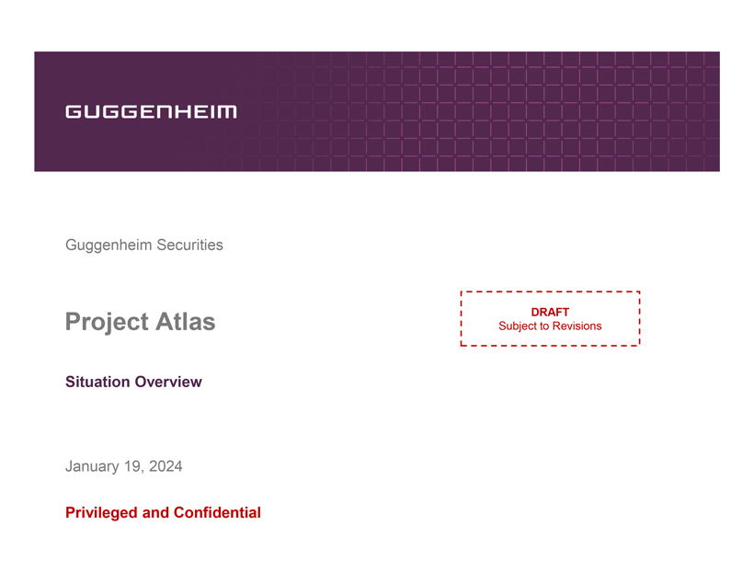
GUGGENHEIM Guggenheim Securities Project Atlas DRAFT Subject to Revisions Situation Overview January 19, 2024 Privileged and Confidential

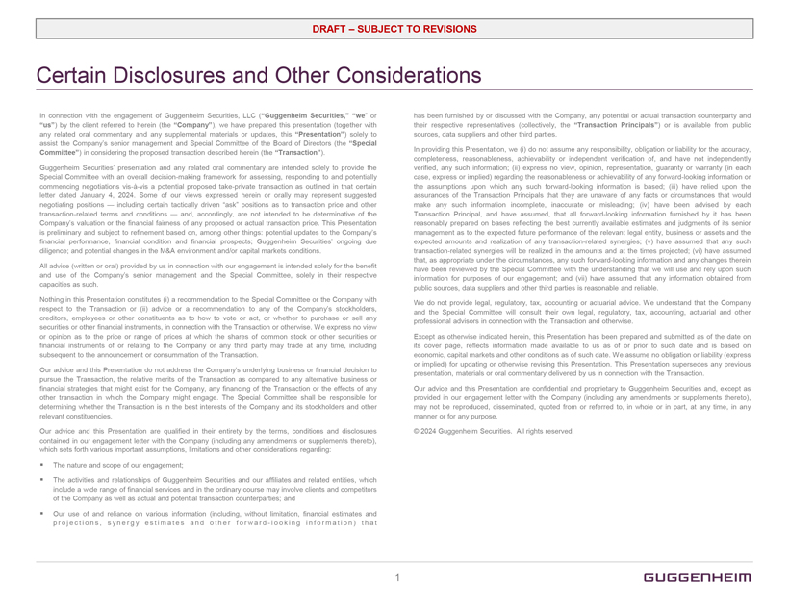
DRAFT  SUBJECT TO REVISIONS Certain Disclosures and Other Considerations In connection with the engagement of Guggenheim Securities, LLC (Guggenheim Securities, we or us) by the client referred to herein (the Company), we have prepared this presentation (together with any related oral commentary and any supplemental materials or updates, this Presentation) solely to assist the Companys senior management and Special Committee of the Board of Directors (the Special Committee) in considering the proposed transaction described herein (the Transaction). Guggenheim Securities presentation and any related oral commentary are intended solely to provide the Special Committee with an overall decision-making framework for assessing, responding to and potentially commencing negotiations vis-à-vis a potential proposed take-private transaction as outlined in that certain letter dated January 4, 2024. Some of our views expressed herein or orally may represent suggested negotiating positions  including certain tactically driven ask positions as to transaction price and other transaction-related terms and conditions  and, accordingly, are not intended to be determinative of the Companys valuation or the financial fairness of any proposed or actual transaction price. This Presentation is preliminary and subject to refinement based on, among other things: potential updates to the Companys financial performance, financial condition and financial prospects; Guggenheim Securities ongoing due diligence; and potential changes in the M&A environment and/or capital markets conditions. All advice (written or oral) provided by us in connection with our engagement is intended solely for the benefit and use of the Companys senior management and the Special Committee, solely in their respective capacities as such. Nothing in this Presentation constitutes (i) a recommendation to the Special Committee or the Company with respect to the Transaction or (ii) advice or a recommendation to any of the Companys stockholders, creditors, employees or other constituents as to how to vote or act, or whether to purchase or sell any securities or other financial instruments, in connection with the Transaction or otherwise. We express no view or opinion as to the price or range of prices at which the shares of common stock or other securities or financial instruments of or relating to the Company or any third party may trade at any time, including subsequent to the announcement or consummation of the Transaction. Our advice and this Presentation do not address the Companys underlying business or financial decision to pursue the Transaction, the relative merits of the Transaction as compared to any alternative business or financial strategies that might exist for the Company, any financing of the Transaction or the effects of any other transaction in which the Company might engage. The Special Committee shall be responsible for determining whether the Transaction is in the best interests of the Company and its stockholders and other relevant constituencies. Our advice and this Presentation are qualified in their entirety by the terms, conditions and disclosures contained in our engagement letter with the Company (including any amendments or supplements thereto), which sets forth various important assumptions, limitations and other considerations regarding: ● The nature and scope of our engagement; ● The activities and relationships of Guggenheim Securities and our affiliates and related entities, which include a wide range of financial services and in the ordinary course may involve clients and competitors of the Company as well as actual and potential transaction counterparties; and ● Our use of and reliance on various information (including, without limitation, financial estimates and projections, synergy estimates and other forward-looking information) that has been furnished by or discussed with the Company, any potential or actual transaction counterparty and their respective representatives (collectively, the Transaction Principals) or is available from public sources, data suppliers and other third parties. In providing this Presentation, we (i) do not assume any responsibility, obligation or liability for the accuracy, completeness, reasonableness, achievability or independent verification of, and have not independently verified, any such information; (ii) express no view, opinion, representation, guaranty or warranty (in each case, express or implied) regarding the reasonableness or achievability of any forward-looking information or the assumptions upon which any such forward-looking information is based; (iii) have relied upon the assurances of the Transaction Principals that they are unaware of any facts or circumstances that would make any such information incomplete, inaccurate or misleading; (iv) have been advised by each Transaction Principal, and have assumed, that all forward-looking information furnished by it has been reasonably prepared on bases reflecting the best currently available estimates and judgments of its senior management as to the expected future performance of the relevant legal entity, business or assets and the expected amounts and realization of any transaction-related synergies; (v) have assumed that any such transaction-related synergies will be realized in the amounts and at the times projected; (vi) have assumed that, as appropriate under the circumstances, any such forward-looking information and any changes therein have been reviewed by the Special Committee with the understanding that we will use and rely upon such information for purposes of our engagement; and (vii) have assumed that any information obtained from public sources, data suppliers and other third parties is reasonable and reliable. We do not provide legal, regulatory, tax, accounting or actuarial advice. We understand that the Company and the Special Committee will consult their own legal, regulatory, tax, accounting, actuarial and other professional advisors in connection with the Transaction and otherwise. Except as otherwise indicated herein, this Presentation has been prepared and submitted as of the date on its cover page, reflects information made available to us as of or prior to such date and is based on economic, capital markets and other conditions as of such date. We assume no obligation or liability (express or implied) for updating or otherwise revising this Presentation. This Presentation supersedes any previous presentation, materials or oral commentary delivered by us in connection with the Transaction. Our advice and this Presentation are confidential and proprietary to Guggenheim Securities and, except as provided in our engagement letter with the Company (including any amendments or supplements thereto), may not be reproduced, disseminated, quoted from or referred to, in whole or in part, at any time, in any manner or for any purpose. © 2024 Guggenheim Securities. All rights reserved. 1 GUGGENHEIM

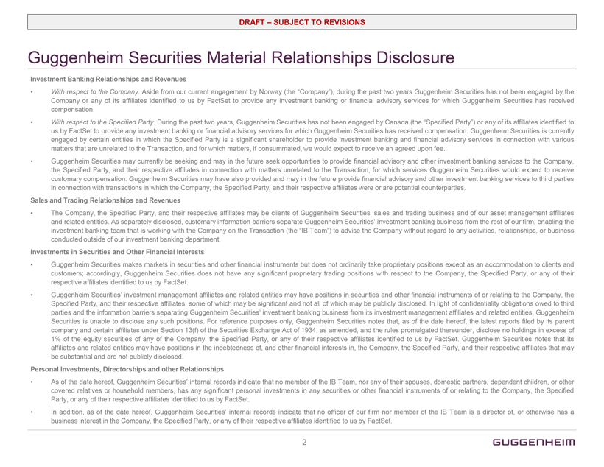
DRAFT  SUBJECT TO REVISIONS Guggenheim Securities Material Relationships Disclosure Investment Banking Relationships and Revenues ● With respect to the Company. Aside from our current engagement by Norway (the Company), during the past two years Guggenheim Securities has not been engaged by the Company or any of its affiliates identified to us by FactSet to provide any investment banking or financial advisory services for which Guggenheim Securities has received compensation. ● With respect to the Specified Party. During the past two years, Guggenheim Securities has not been engaged by Canada (the Specified Party) or any of its affiliates identified to us by FactSet to provide any investment banking or financial advisory services for which Guggenheim Securities has received compensation. Guggenheim Securities is currently engaged by certain entities in which the Specified Party is a significant shareholder to provide investment banking and financial advisory services in connection with various matters that are unrelated to the Transaction, and for which matters, if consummated, we would expect to receive an agreed upon fee. ● Guggenheim Securities may currently be seeking and may in the future seek opportunities to provide financial advisory and other investment banking services to the Company, the Specified Party, and their respective affiliates in connection with matters unrelated to the Transaction, for which services Guggenheim Securities would expect to receive customary compensation. Guggenheim Securities may have also provided and may in the future provide financial advisory and other investment banking services to third parties in connection with transactions in which the Company, the Specified Party, and their respective affiliates were or are potential counterparties. Sales and Trading Relationships and Revenues ● The Company, the Specified Party, and their respective affiliates may be clients of Guggenheim Securities sales and trading business and of our asset management affiliates and related entities. As separately disclosed, customary information barriers separate Guggenheim Securities investment banking business from the rest of our firm, enabling the investment banking team that is working with the Company on the Transaction (the IB Team) to advise the Company without regard to any activities, relationships, or business conducted outside of our investment banking department. Investments in Securities and Other Financial Interests ● Guggenheim Securities makes markets in securities and other financial instruments but does not ordinarily take proprietary positions except as an accommodation to clients and customers; accordingly, Guggenheim Securities does not have any significant proprietary trading positions with respect to the Company, the Specified Party, or any of their respective affiliates identified to us by FactSet. ● Guggenheim Securities investment management affiliates and related entities may have positions in securities and other financial instruments of or relating to the Company, the Specified Party, and their respective affiliates, some of which may be significant and not all of which may be publicly disclosed. In light of confidentiality obligations owed to third parties and the information barriers separating Guggenheim Securities investment banking business from its investment management affiliates and related entities, Guggenheim Securities is unable to disclose any such positions. For reference purposes only, Guggenheim Securities notes that, as of the date hereof, the latest reports filed by its parent company and certain affiliates under Section 13(f) of the Securities Exchange Act of 1934, as amended, and the rules promulgated thereunder, disclose no holdings in excess of 1% of the equity securities of any of the Company, the Specified Party, or any of their respective affiliates identified to us by FactSet. Guggenheim Securities notes that its affiliates and related entities may have positions in the indebtedness of, and other financial interests in, the Company, the Specified Party, and their respective affiliates that may be substantial and are not publicly disclosed. Personal Investments, Directorships and other Relationships ● As of the date hereof, Guggenheim Securities internal records indicate that no member of the IB Team, nor any of their spouses, domestic partners, dependent children, or other covered relatives or household members, has any significant personal investments in any securities or other financial instruments of or relating to the Company, the Specified Party, or any of their respective affiliates identified to us by FactSet. ● In addition, as of the date hereof, Guggenheim Securities internal records indicate that no officer of our firm nor member of the IB Team is a director of, or otherwise has a business interest in the Company, the Specified Party, or any of their respective affiliates identified to us by FactSet. 2 GUGGENHEIM

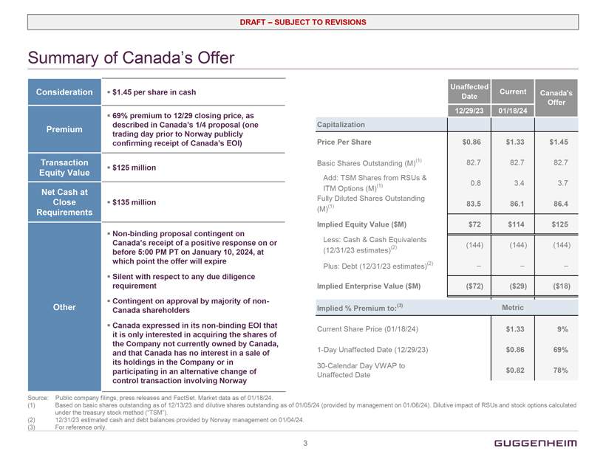
DRAFT  SUBJECT TO REVISIONS Summary of Canadas Offer Consideration ● $1.45 per share in cash Premium ● 69% premium to 12/29 closing price, as described in Canadas 1/4 proposal (one trading day prior to Norway publicly confirming receipt of Canadas EOI) Transaction Equity Value ● $125 million Net Cash at Close Requirements ● $135 million Other ● Non-binding proposal contingent on Canadas receipt of a positive response on or before 5:00 PM PT on January 10, 2024, at which point the offer will expire ● Silent with respect to any due diligence requirement ● Contingent on approval by majority of non- Canada shareholders ● Canada expressed in its non-binding EOI that it is only interested in acquiring the shares of the Company not currently owned by Canada, and that Canada has no interest in a sale of its holdings in the Company or in participating in an alternative change of control transaction involving Norway Unaffected Date 12/29/23 Current 01/18/24 Canadas Offer Capitalization Price Per Share $0.86 $1.33 $1.45 Basic Shares Outstanding (M)(1) 82.7 82.7 82.7 Add: TSM Shares from RSUs & ITM Options (M)(1) 0.8 3.4 3.7 Fully Diluted Shares Outstanding (M)(1) 83.5 86.1 86.4 Implied Equity Value ($M) $72 $114 $125 Less: Cash & Cash Equivalents (12/31/23 estimates)(2) (144) (144) (144) Plus: Debt (12/31/23 estimates)(2)    Implied Enterprise Value ($M) ($72) ($29) ($18) Implied % Premium to:(3) Metric Current Share Price (01/18/24) $1.33 9% 1-Day Unaffected Date (12/29/23) $0.86 69% 30-Calendar Day VWAP to Unaffected Date $0.82 78% Source: Public company filings, press releases and FactSet. Market data as of 01/18/24. (1) Based on basic shares outstanding as of 12/13/23 and dilutive shares outstanding as of 01/05/24 (provided by management on 01/06/24). Dilutive impact of RSUs and stock options calculated under the treasury stock method (TSM). (2) 12/31/23 estimated cash and debt balances provided by Norway management on 01/04/24. (3) For reference only. 3 GUGGENHEIM

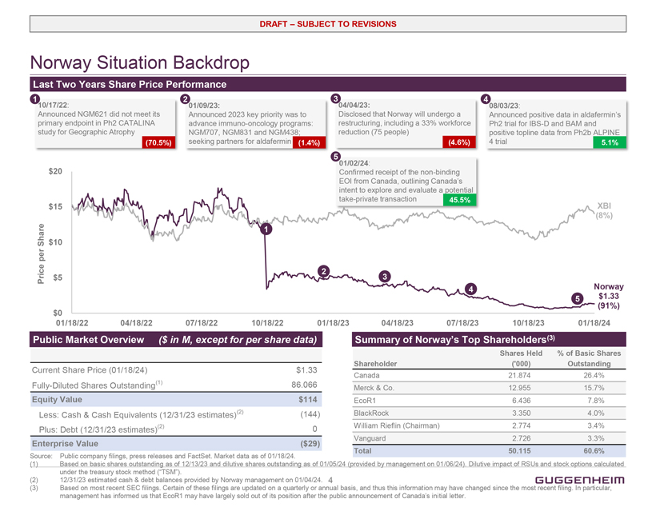
DRAFT  SUBJECT TO REVISIONS Norway Situation Backdrop Last Two Years Share Price Performance 1 10/17/22: Announced NGM621 did not meet its primary endpoint in Ph2 CATALINA study for Geographic Atrophy (70.5%) 2 01/09/23: Announced 2023 key priority was to advance immuno-oncology programs: NGM707, NGM831 and NGM438; seeking partners for aldafermin (1.4%) 3 04/04/23: Disclosed that Norway will undergo a restructuring, including a 33% workforce reduction (75 people) (4.6%) 4 08/03/23: Announced positive data in aldafermins Ph2 trial for IBS-D and BAM and positive topline data from Ph2b ALPINE 4 trial 5.1% 5 01/02/24: Confirmed receipt of the non-binding EOI from Canada, outlining Canadas intent to explore and evaluate a potential take-private transaction 45.5% Price per Share $20 $15 $10 $5 $0 01/18/22 04/18/22 07/18/22 10/18/22 01/18/23 04/18/23 07/18/23 10/18/23 01/18/24 1 2 3 4 5 Norway $1.33 (91%) Public Market Overview ($ in M, except for per share data) Current Share Price (01/18/24) $1.33 Fully-Diluted Shares Outstanding(1) 86.066 Equity Value $114 Less: Cash & Cash Equivalents (12/31/23 estimates)(2) (144) Plus: Debt (12/31/23 estimates)(2) 0 Enterprise Value ($29) Summary of Norways Top Shareholders(3) Shareholder Shares Held (000) % of Basic Shares Outstanding Canada 21.874 26.4% Merck & Co. 12.955 15.7% EcoR1 6.436 7.8% BlackRock 3.350 4.0% William Rieflin (Chairman) 2.774 3.4% Vanguard 2.726 3.3% Total 50.115 60.6% Source: Public company filings, press releases and FactSet. Market data as of 01/18/24. (1) Based on basic shares outstanding as of 12/13/23 and dilutive shares outstanding as of 01/05/24 (provided by management on 01/06/24). Dilutive impact of RSUs and stock options calculated under the treasury stock method (TSM). (2) 12/31/23 estimated cash & debt balances provided by Norway management on 01/04/24.(3) Based on most recent SEC filings. Certain of these filings are updated on a quarterly or annual basis, and thus this information may have changed since the most recent filing. In particular, management has informed us that EcoR1 may have largely sold out of its position after the public announcement of Canadas initial letter. 4 GUGGENHEIM

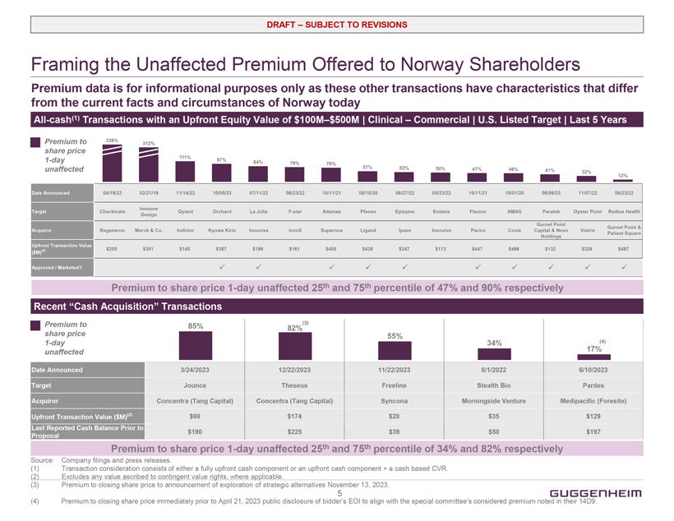
DRAFT  SUBJECT TO REVISIONS Framing the Unaffected Premium Offered to Norway Shareholders Premium data is for informational purposes only as these other transactions have characteristics that differ from the current facts and circumstances of Norway today All-cash(1) Transactions with an Upfront Equity Value of $100M$500M | Clinical  Commercial | U.S. Listed Target | Last 5 Years Premium to share price 1-day unaffected 336% 312% 111% 97% 84% 79% 76% 57% 52% 50% 47% 46% 41% 32% 12% Date Announced 04/19/22 02/21/19 11/14/22 10/05/23 07/11/22 06/23/22 10/11/21 08/10/20 06/27/22 05/23/22 10/11/21 10/01/20 06/06/23 11/07/22 06/23/22 Target Checkmate Immune Design Opiant Orchard La Jolla F-star Adamas Pfenex Epizyme Entasis Flexion AMAG Paratek Oyster Point Radius Health Acquiror Regeneron Merck & Co. Indivior Kyowa Kirin Innoviva invoX Supernus Ligand Ipsen Innoviva Pacira Covis Gurnet Point Capital & Novo Holdings Viatris Gurnet Point & Patient Square Upfront Transaction Value ($M)( 2) $250 $301 $145 $387 $198 $161 $400 $438 $247 $113 $447 $498 $132 $329 $497 Approved / Marketed? Premium to share price 1-day unaffected 25th and 75th percentile of 47% and 90% respectively Recent Cash Acquisition Transactions Premium to share price 1-day unaffected 85% 82%(3) 55% 34% 17%(4) Date Announced 3/24/2023 12/22/2023 11/22/2023 8/1/2022 6/10/2023 Target Jounce Theseus Freeline Stealth Bio Pardes Acquiror Concentra (Tang Capital) Concentra (Tang Capital) Syncona Morningside Venture Medipacific (Foresite) Upfront Transaction Value ($M)(2) $98 $174 $28 $35 $129 Last Reported Cash Balance Prior to Proposal $190 $225 $39 $50 $197 Premium to share price 1-day unaffected 25th and 75th percentile of 34% and 82% respectively Source: Company filings and press releases. (1) Transaction consideration consists of either a fully upfront cash component or an upfront cash component + a cash based CVR. (2) Excludes any value ascribed to contingent value rights, where applicable. (3) Premium to closing share price to announcement of exploration of strategic alternatives November 13, 2023. (4) Premium to closing share price immediately prior to April 21, 2023 public disclosure of bidders EOI to align with the special committees considered premium noted in their 14D9. 5 GUGGENHEIM

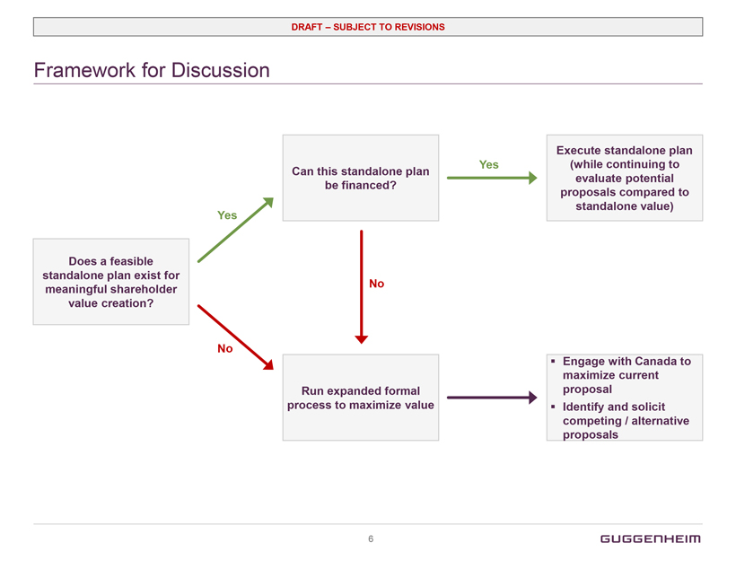
DRAFT  SUBJECT TO REVISIONS Framework for Discussion Does a feasible standalone plan exist for meaningful shareholder value creation? Yes Can this standalone plan be financed? Yes Execute standalone plan (while continuing to evaluate potential proposals compared to standalone value) No Run expanded formal process to maximize value No ● Engage with Canada to maximize current proposal ● Identify and solicit competing / alternative proposals 6 GUGGENHEIM
Exhibit (c)(3)

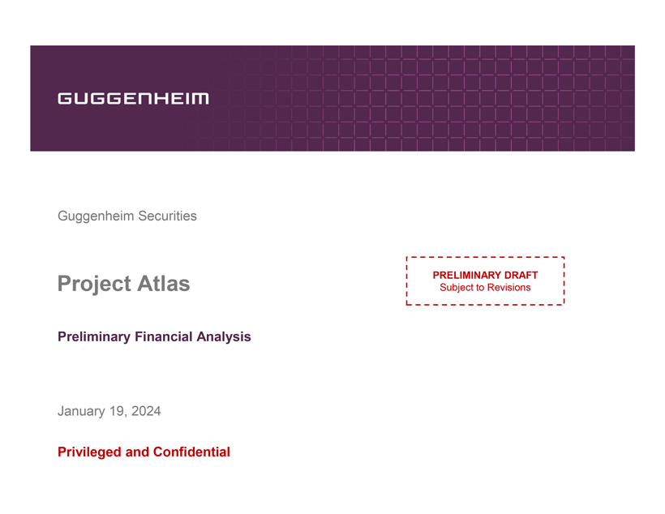
GUGGENHEIM Guggenheim Securities Project Atlas PRELIMINARY DRAFT Subject to Revisions Preliminary Financial Analysis January 19, 2024 Privileged and Confidential

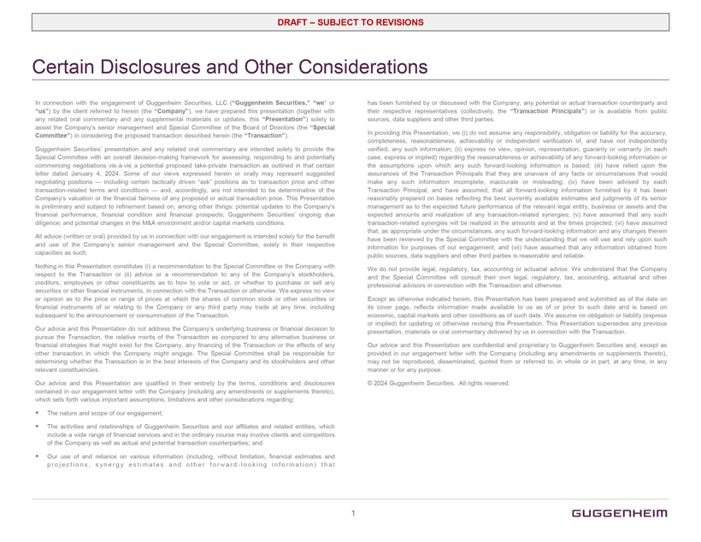
DRAFT  SUBJECT TO REVISIONS Certain Disclosures and Other Considerations In connection with the engagement of Guggenheim Securities, LLC (Guggenheim Securities, we or us) by the client referred to herein (the Company), we have prepared this presentation (together with any related oral commentary and any supplemental materials or updates, this Presentation) solely to assist the Companys senior management and Special Committee of the Board of Directors (the Special Committee) in considering the proposed transaction described herein (the Transaction). Guggenheim Securities presentation and any related oral commentary are intended solely to provide the Special Committee with an overall decision-making framework for assessing, responding to and potentially commencing negotiations vis-à-vis a potential proposed take-private transaction as outlined in that certain letter dated January 4, 2024. Some of our views expressed herein or orally may represent suggested negotiating positions  including certain tactically driven ask positions as to transaction price and other transaction-related terms and conditions  and, accordingly, are not intended to be determinative of the Companys valuation or the financial fairness of any proposed or actual transaction price. This Presentation is preliminary and subject to refinement based on, among other things: potential updates to the Companys financial performance, financial condition and financial prospects; Guggenheim Securities ongoing due diligence; and potential changes in the M&A environment and/or capital markets conditions. All advice (written or oral) provided by us in connection with our engagement is intended solely for the benefit and use of the Companys senior management and the Special Committee, solely in their respective capacities as such. Nothing in this Presentation constitutes (i) a recommendation to the Special Committee or the Company with respect to the Transaction or (ii) advice or a recommendation to any of the Companys stockholders, creditors, employees or other constituents as to how to vote or act, or whether to purchase or sell any securities or other financial instruments, in connection with the Transaction or otherwise. We express no view or opinion as to the price or range of prices at which the shares of common stock or other securities or financial instruments of or relating to the Company or any third party may trade at any time, including subsequent to the announcement or consummation of the Transaction. Our advice and this Presentation do not address the Companys underlying business or financial decision to pursue the Transaction, the relative merits of the Transaction as compared to any alternative business or financial strategies that might exist for the Company, any financing of the Transaction or the effects of any other transaction in which the Company might engage. The Special Committee shall be responsible for determining whether the Transaction is in the best interests of the Company and its stockholders and other relevant constituencies. Our advice and this Presentation are qualified in their entirety by the terms, conditions and disclosures contained in our engagement letter with the Company (including any amendments or supplements thereto), which sets forth various important assumptions, limitations and other considerations regarding: ● The nature and scope of our engagement; ● The activities and relationships of Guggenheim Securities and our affiliates and related entities, which include a wide range of financial services and in the ordinary course may involve clients and competitors of the Company as well as actual and potential transaction counterparties; and ● Our use of and reliance on various information (including, without limitation, financial estimates and projections, synergy estimates and other forward - looking information ) that has been furnished by or discussed with the Company, any potential or actual transaction counterparty and their respective representatives (collectively, the Transaction Principals) or is available from public sources, data suppliers and other third parties. In providing this Presentation, we (i) do not assume any responsibility, obligation or liability for the accuracy, completeness, reasonableness, achievability or independent verification of, and have not independently verified, any such information; (ii) express no view, opinion, representation, guaranty or warranty (in each case, express or implied) regarding the reasonableness or achievability of any forward-looking information or the assumptions upon which any such forward-looking information is based; (iii) have relied upon the assurances of the Transaction Principals that they are unaware of any facts or circumstances that would make any such information incomplete, inaccurate or misleading; (iv) have been advised by each Transaction Principal, and have assumed, that all forward-looking information furnished by it has been reasonably prepared on bases reflecting the best currently available estimates and judgments of its senior management as to the expected future performance of the relevant legal entity, business or assets and the expected amounts and realization of any transaction-related synergies; (v) have assumed that any such transaction-related synergies will be realized in the amounts and at the times projected; (vi) have assumed that, as appropriate under the circumstances, any such forward-looking information and any changes therein have been reviewed by the Special Committee with the understanding that we will use and rely upon such information for purposes of our engagement; and (vii) have assumed that any information obtained from public sources, data suppliers and other third parties is reasonable and reliable. We do not provide legal, regulatory, tax, accounting or actuarial advice. We understand that the Company and the Special Committee will consult their own legal, regulatory, tax, accounting, actuarial and other professional advisors in connection with the Transaction and otherwise. Except as otherwise indicated herein, this Presentation has been prepared and submitted as of the date on its cover page, reflects information made available to us as of or prior to such date and is based on economic, capital markets and other conditions as of such date. We assume no obligation or liability (express or implied) for updating or otherwise revising this Presentation. This Presentation supersedes any previous presentation, materials or oral commentary delivered by us in connection with the Transaction. Our advice and this Presentation are confidential and proprietary to Guggenheim Securities and, except as provided in our engagement letter with the Company (including any amendments or supplements thereto), may not be reproduced, disseminated, quoted from or referred to, in whole or in part, at any time, in any manner or for any purpose. © 2024 Guggenheim Securities. All rights reserved. 1 GUGGENHEIM

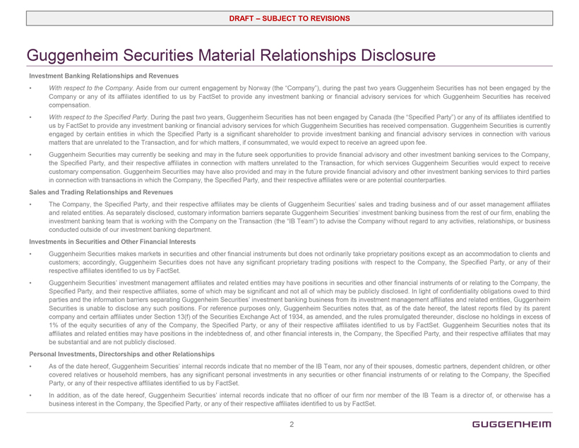
DRAFT  SUBJECT TO REVISIONS Guggenheim Securities Material Relationships Disclosure Investment Banking Relationships and Revenues ● With respect to the Company. Aside from our current engagement by Norway (the Company), during the past two years Guggenheim Securities has not been engaged by the Company or any of its affiliates identified to us by FactSet to provide any investment banking or financial advisory services for which Guggenheim Securities has received compensation. ● With respect to the Specified Party. During the past two years, Guggenheim Securities has not been engaged by Canada (the Specified Party) or any of its affiliates identified to us by FactSet to provide any investment banking or financial advisory services for which Guggenheim Securities has received compensation. Guggenheim Securities is currently engaged by certain entities in which the Specified Party is a significant shareholder to provide investment banking and financial advisory services in connection with various matters that are unrelated to the Transaction, and for which matters, if consummated, we would expect to receive an agreed upon fee. ● Guggenheim Securities may currently be seeking and may in the future seek opportunities to provide financial advisory and other investment banking services to the Company, the Specified Party, and their respective affiliates in connection with matters unrelated to the Transaction, for which services Guggenheim Securities would expect to receive customary compensation.Guggenheim Securities may have also provided and may in the future provide financial advisory and other investment banking services to third parties in connection with transactions in which the Company, the Specified Party, and their respective affiliates were or are potential counterparties. Sales and Trading Relationships and Revenues ● The Company, the Specified Party, and their respective affiliates may be clients of Guggenheim Securities sales and trading business and of our asset management affiliates and related entities. As separately disclosed, customary information barriers separate Guggenheim Securities investment banking business from the rest of our firm, enabling the investment banking team that is working with the Company on the Transaction (the IB Team) to advise the Company without regard to any activities, relationships, or business conducted outside of our investment banking department. Investments in Securities and Other Financial Interests ● Guggenheim Securities makes markets in securities and other financial instruments but does not ordinarily take proprietary positions except as an accommodation to clients and customers; accordingly, Guggenheim Securities does not have any significant proprietary trading positions with respect to the Company, the Specified Party, or any of their respective affiliates identified to us by FactSet. ● Guggenheim Securities investment management affiliates and related entities may have positions in securities and other financial instruments of or relating to the Company, the Specified Party, and their respective affiliates, some of which may be significant and not all of which may be publicly disclosed. In light of confidentiality obligations owed to third parties and the information barriers separating Guggenheim Securities investment banking business from its investment management affiliates and related entities, Guggenheim Securities is unable to disclose any such positions. For reference purposes only, Guggenheim Securities notes that, as of the date hereof, the latest reports filed by its parent company and certain affiliates under Section 13(f) of the Securities Exchange Act of 1934, as amended, and the rules promulgated thereunder, disclose no holdings in excess of 1% of the equity securities of any of the Company, the Specified Party, or any of their respective affiliates identified to us by FactSet. Guggenheim Securities notes that its affiliates and related entities may have positions in the indebtedness of, and other financial interests in, the Company, the Specified Party, and their respective affiliates that may be substantial and are not publicly disclosed. Personal Investments, Directorships and other Relationships ● As of the date hereof, Guggenheim Securities internal records indicate that no member of the IB Team, nor any of their spouses, domestic partners, dependent children, or other covered relatives or household members, has any significant personal investments in any securities or other financial instruments of or relating to the Company, the Specified Party, or any of their respective affiliates identified to us by FactSet. ● In addition, as of the date hereof, Guggenheim Securities internal records indicate that no officer of our firm nor member of the IB Team is a director of, or otherwise has a business interest in the Company, the Specified Party, or any of their respective affiliates identified to us by FactSet. 2 GUGGENHEIM

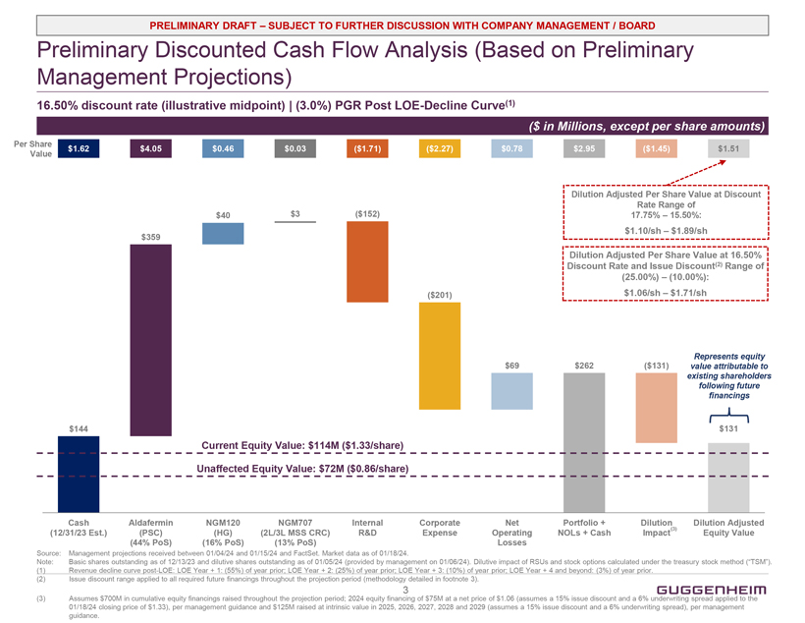
PRELIMINARY DRAFT  SUBJECT TO FURTHER DISCUSSION WITH COMPANY MANAGEMENT / BOARD Preliminary Discounted Cash Flow Analysis (Based on Preliminary Management Projections) 16.50% discount rate (illustrative midpoint) | (3.0%) PGR Post LOE-Decline Curve(1) ($ in Millions, except per share amounts) Per Share Value $1.62 $4.05 $0.46 $0.03 ($1.71) ($2.27) $0.78 $2.95 ($1.45) $1.51 Dilution Adjusted Per Share Value at Discount Rate Range of 17.75%  15.50%: $1.10/sh  $1.89/sh Dilution Adjusted Per Share Value at 16.50% Discount Rate and Issue Discount(2) Range of (25.00%)  (10.00%): $1.06/sh  $1.71/sh $144 $359 $40 $3 ($152) ($201) $69 $262 ($131) Represents equity value attributable to existing shareholders following future financings $131 Current Equity Value: $114M ($1.33/share) Unaffected Equity Value: $72M ($0.86/share) Cash (12/31/23 Est.) Aldafermin (PSC) (44% PoS) NGM120 (HG) (16% PoS) NGM707 (2L/3L MSS CRC) (13% PoS) Internal R&D Corporate Expense Net Operating Losses Portfolio + NOLs + Cash Dilution Impact(3) Dilution Adjusted Equity Value Source: Management projections received between 01/04/24 and 01/15/24 and FactSet. Market data as of 01/18/24. Note: Basic shares outstanding as of 12/13/23 and dilutive shares outstanding as of 01/05/24 (provided by management on 01/06/24). Dilutive impact of RSUs and stock options calculated under the treasury stock method (TSM). (1) Revenue decline curve post-LOE: LOE Year + 1: (55%) of year prior; LOE Year + 2: (25%) of year prior; LOE Year + 3: (10%) of year prior; LOE Year + 4 and beyond: (3%) of year prior. (2) Issue discount range applied to all required future financings throughout the projection period (methodology detailed in footnote 3). (3) Assumes $700M in cumulative equity financings raised throughout the projection period; 2024 equity financing of $75M at a net price of $1.06 (assumes a 15% issue discount and a 6% underwriting spread applied to the 01/18/24 closing price of $1.33), per management guidance and $125M raised at intrinsic value in 2025, 2026, 2027, 2028 and 2029 (assumes a 15% issue discount and a 6% underwriting spread), per management guidance. 3 GUGGENHEIM

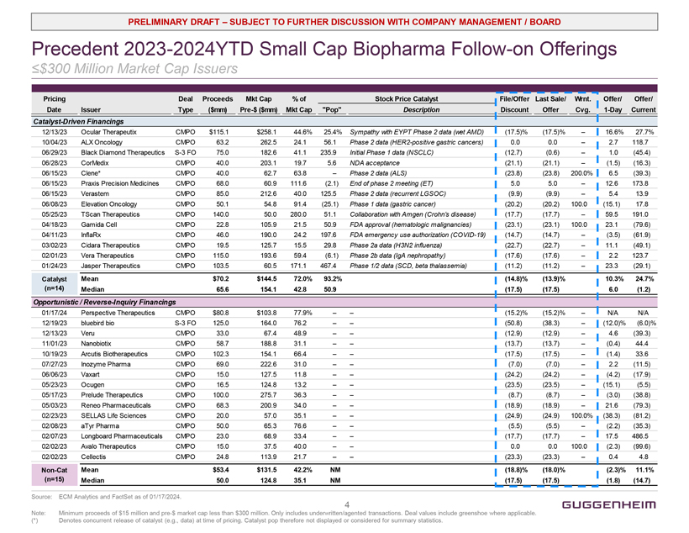
PRELIMINARY DRAFT  SUBJECT TO FURTHER DISCUSSION WITH COMPANY MANAGEMENT / BOARD Precedent 2023-2024YTD Small Cap Biopharma Follow-on Offerings ≤$300 Million Market Cap Issuers Pricing Date Issuer Deal Type Proceeds ($mm) Mkt Cap Pre-$ ($mm) % of Mkt Cap Pop Stock Price Catalyst Description File/Offer Discount Last Sale/ Offer Wrnt. Cvg. Offer/ 1-Day Offer/Current Catalyst-Driven Financings 12/13/23 Ocular Therapeutix CMPO $115.1 $258.1 44.6% 25.4% Sympathy with EYPT Phase 2 data (wet AMD) (17.5)% (17.5)%  16.6% 27.7% 10/04/23 ALX Oncology CMPO 63.2 262.5 24.1 56.1 Phase 2 data (HER2-positive gastric cancers) 0.0 0.0  2.7 118.7 06/29/23 Black Diamond Therapeutics S-3 FO 75.0 182.6 41.1 235.9 Initial Phase 1 data (NSCLC) (12.7) (0.6)  1.0 (45.4) 06/28/23 CorMedix CMPO 40.0 203.1 19.7 5.6 NDA acceptance (21.1) (21.1)  (1.5) (16.3) 06/15/23 Clene* CMPO 40.0 62.7 63.8  Phase 2 data (ALS) (23.8) (23.8) 200.0% 6.5 (39.3) 06/15/23 Praxis Precision Medicines CMPO 68.0 60.9 111.6 (2.1) End of phase 2 meeting (ET) 5.0 5.0  12.6 173.8 06/15/23 Verastem CMPO 85.0 212.6 40.0 125.5 Phase 2 data (recurrent LGSOC) (9.9) (9.9)  5.4 13.9 06/08/23 Elevation Oncology CMPO 50.1 54.8 91.4 (25.1) Phase 1 data (gastric cancer) (20.2) (20.2) 100.0 (15.1) 17.8 05/25/23 TScan Therapeutics CMPO 140.0 50.0 280.0 51.1 Collaboration with Amgen (Crohns disease) (17.7) (17.7)  59.5 191.0 04/18/23 Gamida Cell CMPO 22.8 105.9 21.5 50.9 FDA approval (hematologic malignancies) (23.1) (23.1) 100.0 23.1 (79.6) 04/11/23 InflaRx CMPO 46.0 190.0 24.2 197.6 FDA emergency use authorization (COVID-19) (14.7) (14.7)  (3.5) (61.9) 03/02/23 Cidara Therapeutics CMPO 19.5 125.7 15.5 29.8 Phase 2a data (H3N2 influenza) (22.7) (22.7)  11.1 (49.1) 02/01/23 Vera Therapeutics CMPO 115.0 193.6 59.4 (6.1) Phase 2b data (IgA nephropathy) (17.6) (17.6)  2.2 123.7 01/24/23 Jasper Therapeutics CMPO 103.5 60.5 171.1 467.4 Phase 1/2 data (SCD, beta thalassemia) (11.2) (11.2)  23.3 (29.1) Catalyst Mean $70.2 $144.5 72.0% 93.2% (14.8)% (13.9)% 10.3% 24.7% (n=14) Median 65.6 154.1 42.8 50.9 (17.5) (17.5) 6.0 (1.2) Opportunistic / Reverse-Inquiry Financings 01/17/24 Perspective Therapeutics CMPO $80.8 $103.8 77.9%   (15.2)% (15.2)%  N/A N/A 12/19/23 bluebird bio S-3 FO 125.0 164.0 76.2   (50.8) (38.3)  (12.0)% (6.0)% 12/13/23 Veru CMPO 33.0 67.4 48.9   (12.9) (12.9)  4.6 (39.3) 11/01/23 Nanobiotix CMPO 58.7 188.8 31.1   (13.7) (13.7)  (0.4) 44.4 10/19/23 Arcutis Biotherapeutics CMPO 102.3 154.1 66.4   (17.5) (17.5)  (1.4) 33.6 07/27/23 Inozyme Pharma CMPO 69.0 222.6 31.0   (7.0) (7.0)  2.2 (11.5) 06/06/23 Vaxart CMPO 15.0 127.5 11.8   (24.2) (24.2)  (4.2) (17.9) 05/23/23 Ocugen CMPO 16.5 124.8 13.2   (23.5) (23.5)  (15.1) (5.5) 05/17/23 Prelude Therapeutics CMPO 100.0 275.7 36.3   (8.7) (8.7)  (3.0) (38.8) 05/03/23 Reneo Pharmaceuticals CMPO 68.3 200.9 34.0   (18.9) (18.9)  21.6 (79.3) 02/23/23 SELLAS Life Sciences CMPO 20.0 57.0 35.1   (24.9) (24.9) 100.0% (38.3) (81.2) 02/08/23 aTyr Pharma CMPO 50.0 65.3 76.6   (5.5) (5.5)  (2.2) (35.3) 02/07/23 Longboard Pharmaceuticals CMPO 23.0 68.9 33.4   (17.7) (17.7)  17.5 486.5 02/02/23 Avalo Therapeutics CMPO 15.0 37.5 40.0   0.0 0.0 100.0 (2.3) (99.6) 02/02/23 Cellectis CMPO 24.8 113.9 21.7   (23.3) (23.3)  0.4 4.8 Non-Cat Mean $53.4 $131.5 42.2% NM (18.8)% (18.0)% (2.3)% 11.1% (n=15) Median 50.0 124.8 35.1 NM (17.5) (17.5) (1.8) (14.7) Source: ECM Analytics and FactSet as of 01/17/2024. Note: Minimum proceeds of $15 million and pre-$ market cap less than $300 million. Only includes underwritten/agented transactions. Deal values include greenshoe where applicable. (*) Denotes concurrent release of catalyst (e.g., data) at time of pricing. Catalyst pop therefore not displayed or considered for summary statistics. 4 GUGGENHEIM
Exhibit (c)(4)


GUGGENHEIM GUGGENHEIM Securities Project Atlas Presentation to the Special Committee of the Board of Directors February 25, 2024 Privileged and Confidential

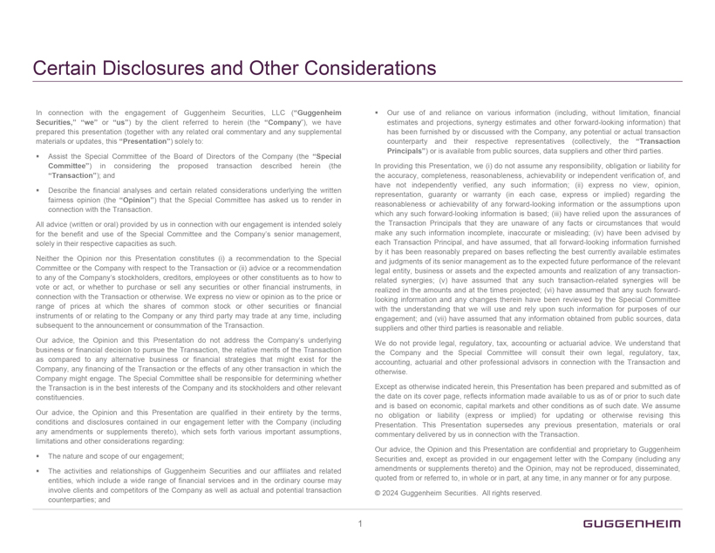
Certain Disclosures and Other Considerations In connection with the engagement of Guggenheim Securities, LLC (Guggenheim Securities, we or us) by the client referred to herein (the Company), we have prepared this presentation (together with any related oral commentary and any supplemental materials or updates, this Presentation) solely to: Assist the Special Committee of the Board of Directors of the Company (the Special Committee) in considering the proposed transaction described herein (the Transaction); and ? Describe the financial analyses and certain related considerations underlying the written fairness opinion (the Opinion) that the Special Committee has asked us to render in connection with the Transaction. All advice (written or oral) provided by us in connection with our engagement is intended solely for the benefit and use of the Special Committee and the Companys senior management, solely in their respective capacities as such. Neither the Opinion nor this Presentation constitutes (i) a recommendation to the Special Committee or the Company with respect to the Transaction or (ii) advice or a recommendation to any of the Companys stockholders, creditors, employees or other constituents as to how to vote or act, or whether to purchase or sell any securities or other financial instruments, in connection with the Transaction or otherwise. We express no view or opinion as to the price or range of prices at which the shares of common stock or other securities or financial instruments of or relating to the Company or any third party may trade at any time, including subsequent to the announcement or consummation of the Transaction. Our advice, the Opinion and this Presentation do not address the Companys underlying business or financial decision to pursue the Transaction, the relative merits of the Transaction as compared to any alternative business or financial strategies that might exist for the Company, any financing of the Transaction or the effects of any other transaction in which the Company might engage. The Special Committee shall be responsible for determining whether the Transaction is in the best interests of the Company and its stockholders and other relevant constituencies. Our advice, the Opinion and this Presentation are qualified in their entirety by the terms, conditions and disclosures contained in our engagement letter with the Company (including any amendments or supplements thereto), which sets forth various important assumptions, limitations and other considerations regarding: The nature and scope of our engagement; ? The activities and relationships of Guggenheim Securities and our affiliates and related entities, which include a wide range of financial services and in the ordinary course may involve clients and competitors of the Company as well as actual and potential transaction counterparties; and Our use of and reliance on various information (including, without limitation, financial estimates and projections, synergy estimates and other forward-looking information) that has been furnished by or discussed with the Company, any potential or actual transaction counterparty and their respective representatives (collectively, the Transaction Principals) or is available from public sources, data suppliers and other third parties. In providing this Presentation, we (i) do not assume any responsibility, obligation or liability for the accuracy, completeness, reasonableness, achievability or independent verification of, and have not independently verified, any such information; (ii) express no view, opinion, representation, guaranty or warranty (in each case, express or implied) regarding the reasonableness or achievability of any forward-looking information or the assumptions upon which any such forward-looking information is based; (iii) have relied upon the assurances of the Transaction Principals that they are unaware of any facts or circumstances that would make any such information incomplete, inaccurate or misleading; (iv) have been advised by each Transaction Principal, and have assumed, that all forward-looking information furnished by it has been reasonably prepared on bases reflecting the best currently available estimates and judgments of its senior management as to the expected future performance of the relevant legal entity, business or assets and the expected amounts and realization of any transactionrelated synergies; (v) have assumed that any such transaction-related synergies will be realized in the amounts and at the times projected; (vi) have assumed that any such forwardlooking information and any changes therein have been reviewed by the Special Committee with the understanding that we will use and rely upon such information for purposes of our engagement; and (vii) have assumed that any information obtained from public sources, data suppliers and other third parties is reasonable and reliable. We do not provide legal, regulatory, tax, accounting or actuarial advice. We understand that the Company and the Special Committee will consult their own legal, regulatory, tax, accounting, actuarial and other professional advisors in connection with the Transaction and otherwise. Except as otherwise indicated herein, this Presentation has been prepared and submitted as of the date on its cover page, reflects information made available to us as of or prior to such date and is based on economic, capital markets and other conditions as of such date. We assume no obligation or liability (express or implied) for updating or otherwise revising this Presentation. This Presentation supersedes any previous presentation, materials or oral commentary delivered by us in connection with the Transaction. Our advice, the Opinion and this Presentation are confidential and proprietary to Guggenheim Securities and, except as provided in our engagement letter with the Company (including any amendments or supplements thereto) and the Opinion, may not be reproduced, disseminated, quoted from or referred to, in whole or in part, at any time, in any manner or for any purpose. © 2024 Guggenheim Securities. All rights reserved. GUGGENHEIM 1

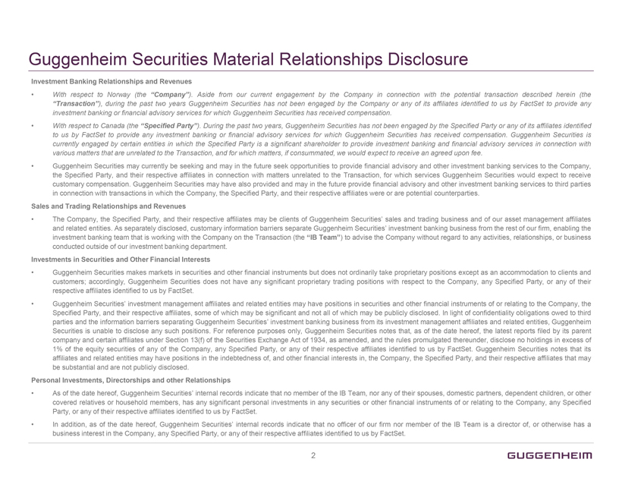
Guggenheim Securities Material Relationships Disclosure Investment Banking Relationships and Revenues With respect to Norway (the Company). Aside from our current engagement by the Company in connection with the potential transaction described herein (the Transaction), during the past two years Guggenheim Securities has not been engaged by the Company or any of its affiliates identified to us by FactSet to provide any investment banking or financial advisory services for which Guggenheim Securities has received compensation. With respect to Canada (the Specified Party). During the past two years, Guggenheim Securities has not been engaged by the Specified Party or any of its affiliates identified to us by FactSet to provide any investment banking or financial advisory services for which Guggenheim Securities has received compensation. Guggenheim Securities is currently engaged by certain entities in which the Specified Party is a significant shareholder to provide investment banking and financial advisory services in connection with various matters that are unrelated to the Transaction, and for which matters, if consummated, we would expect to receive an agreed upon fee. Guggenheim Securities may currently be seeking and may in the future seek opportunities to provide financial advisory and other investment banking services to the Company, the Specified Party, and their respective affiliates in connection with matters unrelated to the Transaction, for which services Guggenheim Securities would expect to receive customary compensation. Guggenheim Securities may have also provided and may in the future provide financial advisory and other investment banking services to third parties in connection with transactions in which the Company, the Specified Party, and their respective affiliates were or are potential counterparties. Sales and Trading Relationships and Revenues The Company, the Specified Party, and their respective affiliates may be clients of Guggenheim Securities sales and trading business and of our asset management affiliates and related entities. As separately disclosed, customary information barriers separate Guggenheim Securities investment banking business from the rest of our firm, enabling the investment banking team that is working with the Company on the Transaction (the IB Team) to advise the Company without regard to any activities, relationships, or business conducted outside of our investment banking department. Investments in Securities and Other Financial Interests Guggenheim Securities makes markets in securities and other financial instruments but does not ordinarily take proprietary positions except as an accommodation to clients and customers; accordingly, Guggenheim Securities does not have any significant proprietary trading positions with respect to the Company, any Specified Party, or any of their respective affiliates identified to us by FactSet. Guggenheim Securities investment management affiliates and related entities may have positions in securities and other financial instruments of or relating to the Company, the Specified Party, and their respective affiliates, some of which may be significant and not all of which may be publicly disclosed. In light of confidentiality obligations owed to third parties and the information barriers separating Guggenheim Securities investment banking business from its investment management affiliates and related entities, Guggenheim Securities is unable to disclose any such positions. For reference purposes only, Guggenheim Securities notes that, as of the date hereof, the latest reports filed by its parent company and certain affiliates under Section 13(f) of the Securities Exchange Act of 1934, as amended, and the rules promulgated thereunder, disclose no holdings in excess of 1% of the equity securities of any of the Company, any Specified Party, or any of their respective affiliates identified to us by FactSet. Guggenheim Securities notes that its affiliates and related entities may have positions in the indebtedness of, and other financial interests in, the Company, the Specified Party, and their respective affiliates that may be substantial and are not publicly disclosed. Personal Investments, Directorships and other Relationships As of the date hereof, Guggenheim Securities internal records indicate that no member of the IB Team, nor any of their spouses, domestic partners, dependent children, or other covered relatives or household members, has any significant personal investments in any securities or other financial instruments of or relating to the Company, any Specified Party, or any of their respective affiliates identified to us by FactSet. In addition, as of the date hereof, Guggenheim Securities internal records indicate that no officer of our firm nor member of the IB Team is a director of, or otherwise has a business interest in the Company, any Specified Party, or any of their respective affiliates identified to us by FactSet. GUGGENHEIM 2

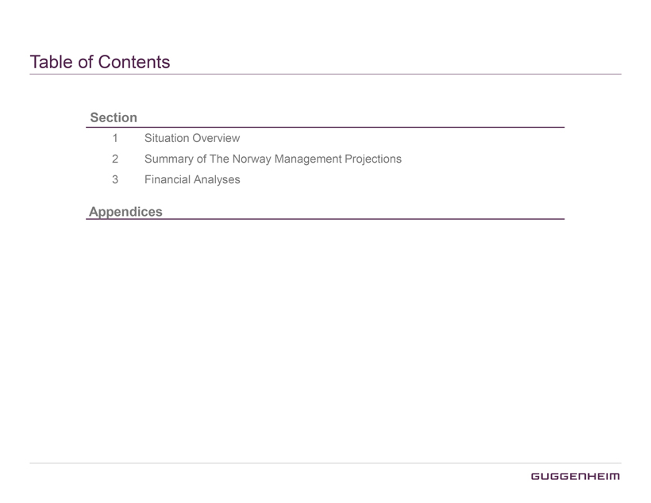
Table of Contents Section 1 Situation Overview 2 Summary of The Norway Management Projections 3 Financial Analyses Appendices GUGGENHEIM

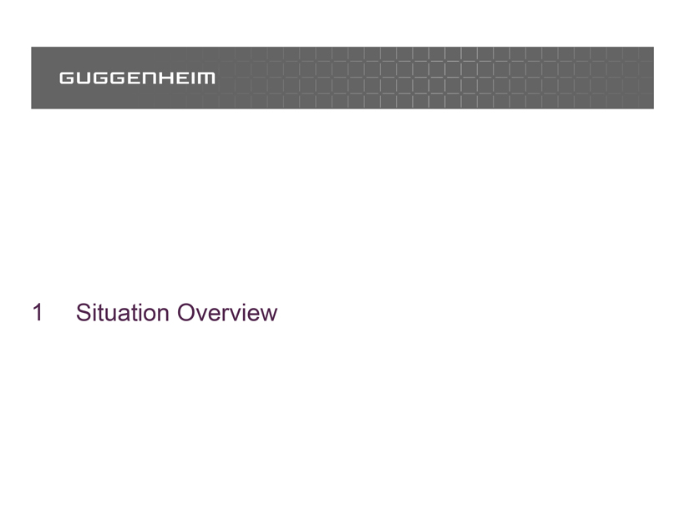
GUGGENHEIM 1 Situation Overview

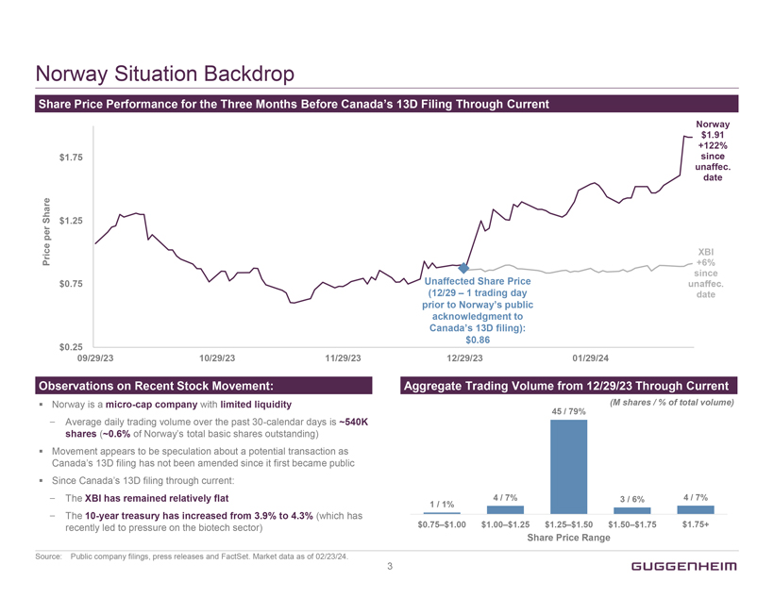
Norway Situation Backdrop Share Price Performance for the Three Months Before Canadas 13D Filing Through Current Price per Share $1.75 $1.25 $0.75 $0.25 Unaffected Share Price (12/29  1 trading day prior to Norways public acknowledgment to Canadas 13D filing): $0.86 Norway $1.91 +122% since unaffec. Date XBI +6% since unaffec. Date 09/29/23 10/29/23 11/29/23 12/29/23 01/29/24 Observations on Recent Stock Movement: Norway is a micro-cap company with limited liquidity  Average daily trading volume over the past 30-calendar days is ~540K shares (~0.6% of Norways total basic shares outstanding)  Movement appears to be speculation about a potential transaction as Canadas 13D filing has not been amended since it first became public Since Canadas 13D filing through current:  The XBI has remained relatively flat  The 10-year treasury has increased from 3.9% to 4.3% (which has recently led to pressure on the biotech sector) Aggregate Trading Volume from 12/29/23 Through Current (M shares / % of total volume) 1 / 1% 4 / 7% 45 / 79% 3 / 6% 4 / 7% $0.75$1.00 $1.00$1.25 $1.25$1.50 $1.50$1.75 $1.75+ Share Price Range Source: Public company filings, press releases and FactSet. Market data as of 02/23/24. GUGGENHEIM 3

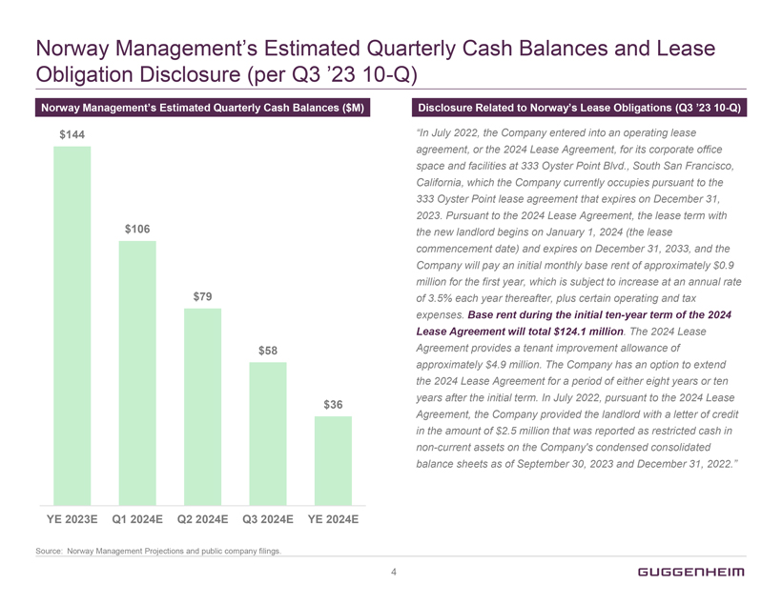
Norway Managements Estimated Quarterly Cash Balances and Lease Obligation Disclosure (per Q3 23 10-Q) Norway Managements Estimated Quarterly Cash Balances ($M) $144 $106 $79 $58 $36 YE 2023E Q1 2024E Q2 2024E Q3 2024E YE 2024E Disclosure Related to Norways Lease Obligations (Q3 23 10-Q) In July 2022, the Company entered into an operating lease agreement, or the 2024 Lease Agreement, for its corporate office space and facilities at 333 Oyster Point Blvd., South San Francisco, California, which the Company currently occupies pursuant to the 333 Oyster Point lease agreement that expires on December 31, 2023. Pursuant to the 2024 Lease Agreement, the lease term with the new landlord begins on January 1, 2024 (the lease commencement date) and expires on December 31, 2033, and the Company will pay an initial monthly base rent of approximately $0.9 million for the first year, which is subject to increase at an annual rate of 3.5% each year thereafter, plus certain operating and tax expenses. Base rent during the initial ten-year term of the 2024 Lease Agreement will total $124.1 million. The 2024 Lease Agreement provides a tenant improvement allowance of approximately $4.9 million. The Company has an option to extend the 2024 Lease Agreement for a period of either eight years or ten years after the initial term. In July 2022, pursuant to the 2024 Lease Agreement, the Company provided the landlord with a letter of credit in the amount of $2.5 million that was reported as restricted cash in non-current assets on the Companys condensed consolidated balance sheets as of September 30, 2023 and December 31, 2022. Source: Norway Management Projections and public company filings. GUGGENHEIM 4

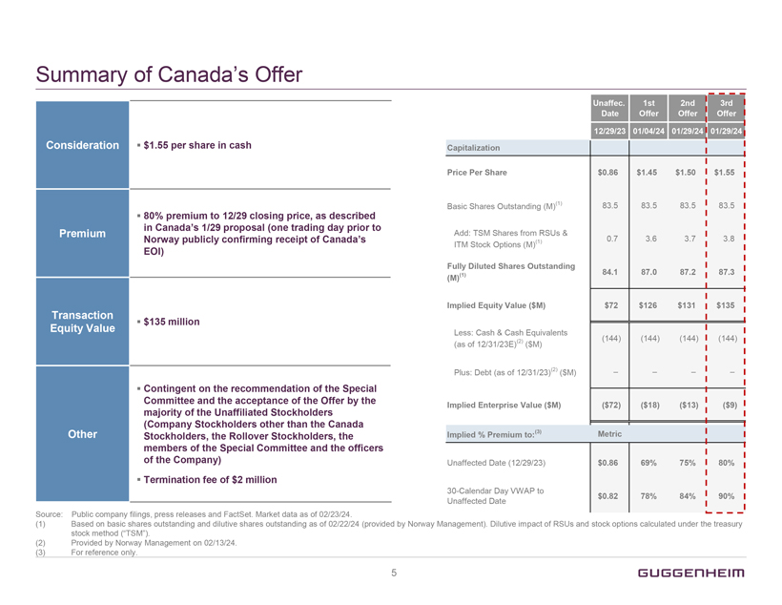
Summary of Canadas Offer Consideration $1.55 per share in cash Premium 80% premium to 12/29 closing price, as described in Canadas 1/29 proposal (one trading day prior to Norway publicly confirming receipt of Canadas EOI) Transaction Equity Value $135 million Other Contingent on the recommendation of the Special Committee and the acceptance of the Offer by the majority of the Unaffiliated Stockholders (Company Stockholders other than the Canada Stockholders, the Rollover Stockholders, the members of the Special Committee and the officers of the Company) Termination fee of $2 million Unaffec. Date 1st Offer 2nd Offer 3rd Offer 12/29/23 01/04/24 01/29/24 01/29/24 Capitalization Price Per Share $0.86 $1.45 $1.50 $1.55 Basic Shares Outstanding (M)(1) 83.5 83.5 83.5 83.5 Add: TSM Shares from RSUs & amp; ITM Stock Options (M)(1) 0.7 3.6 3.7 3.8 Fully Diluted Shares Outstanding (M)(1) 84.1 87.0 87.2 87.3 Implied Equity Value ($M) $72 $126 $131 $135 Less: Cash & Cash Equivalents (as of 12/31/23E)(2) ($M) (144) (144) (144) (144) Plus: Debt (as of 12/31/23)(2) ($M)     Implied Enterprise Value ($M) ($72) ($18) ($13) ($9) Implied % Premium to:(3) Metric Unaffected Date (12/29/23) $0.86 69% 75% 80% 30-Calendar Day VWAP to Unaffected Date $0.82 78% 84% 90% Source: Public company filings, press releases and FactSet. Market data as of 02/23/24. (1) Based on basic shares outstanding and dilutive shares outstanding as of 02/22/24 (provided by Norway Management). Dilutive impact of RSUs and stock options calculated under the treasury stock method (TSM). (2) Provided by Norway Management on 02/13/24. (3) For reference only. GUGGENHEIM 5

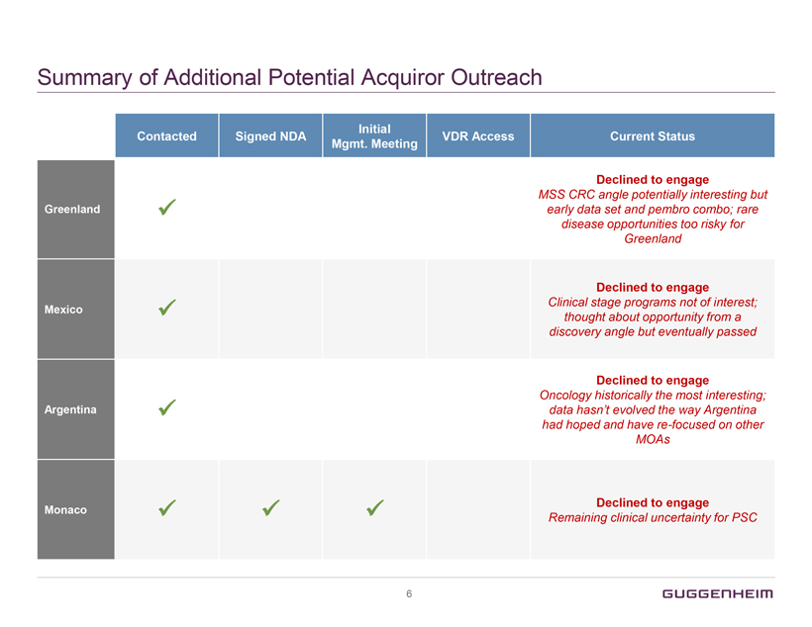
Summary of Additional Potential Acquiror Outreach Contacted Signed NDA Initial Mgmt. Meeting VDR Access Current Status Greenland ✓ Declined to engage MSS CRC angle potentially interesting but early data set and pembro combo; rare disease opportunities too risky for Greenland Mexico ✓ Declined to engage Clinical stage programs not of interest; thought about opportunity from a discovery angle but eventually passed Argentina ✓ Declined to engage Oncology historically the most interesting; data hasnt evolved the way Argentina had hoped and have re-focused on other MOAs Monaco ✓ ✓ ✓ Declined to engage Remaining clinical uncertainty for PSC GUGGENHEIM 6

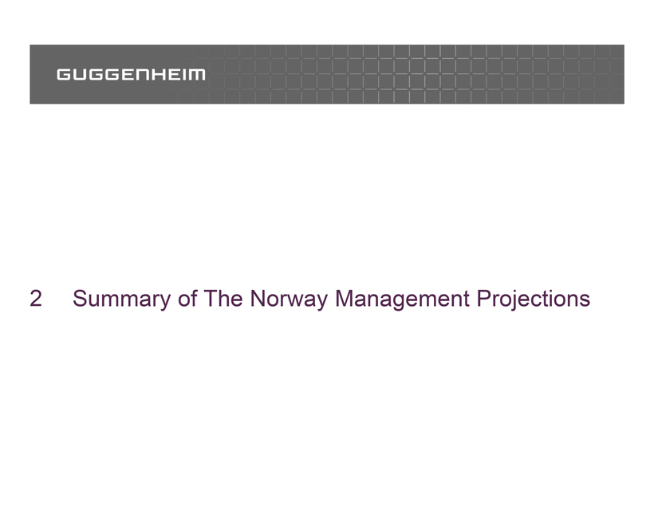
GUGGENHEIM 2 Summary of The Norway Management Projections

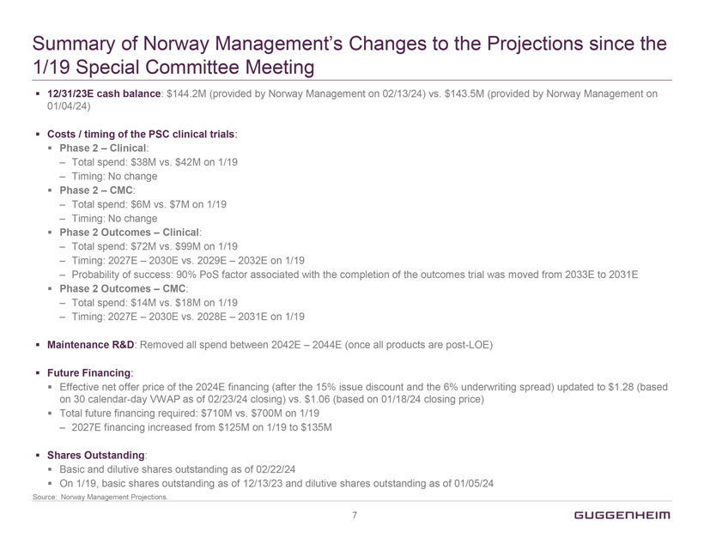
Summary of Norway Managements Changes to the Projections since the 1/19 Special Committee Meeting 12/31/23E cash balance: $144.2M (provided by Norway Management on 02/13/24) vs. $143.5M (provided by Norway Management on 01/04/24) Costs / timing of the PSC clinical trials: Phase 2  Clinical:  Total spend: $38M vs. $42M on 1/19  Timing: No change Phase 2  CMC:  Total spend: $6M vs. $7M on 1/19  Timing: No change Phase 2 Outcomes  Clinical:  Total spend: $72M vs. $99M on 1/19  Timing: 2027E  2030E vs. 2029E  2032E on 1/19  Probability of success: 90% PoS factor associated with the completion of the outcomes trial was moved from 2033E to 2031E Phase 2 Outcomes  CMC:  Total spend: $14M vs. $18M on 1/19  Timing: 2027E  2030E vs. 2028E  2031E on 1/19 Maintenance R&D: Removed all spend between 2042E  2044E (once all products are post-LOE) Future Financing: Effective net offer price of the 2024E financing (after the 15% issue discount and the 6% underwriting spread) updated to $1.28 (based on 30 calendar-day VWAP as of 02/23/24 closing) vs. $1.06 (based on 01/18/24 closing price) Total future financing required: $710M vs. $700M on 1/19  2027E financing increased from $125M on 1/19 to $135M Shares Outstanding: Basic and dilutive shares outstanding as of 02/22/24 On 1/19, basic shares outstanding as of 12/13/23 and dilutive shares outstanding as of 01/05/24 Source: Norway Management Projections. GUGGENHEIM 7

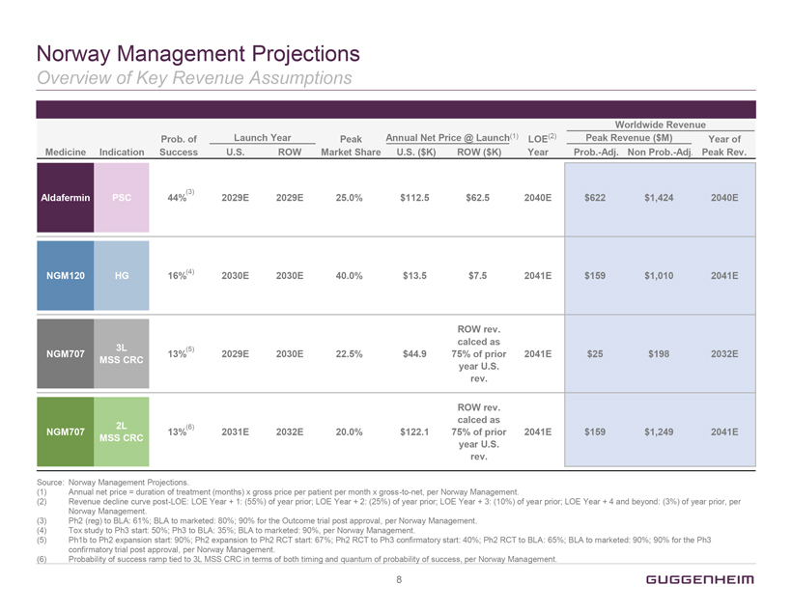
Norway Management Projections Overview of Key Revenue Assumptions Medicine Indication Prob. of Success Launch Year U.S. ROW Peak Market Share Annual Net Price @ Launch(1) U.S. ($K) ROW ($K) LOE(2) Year Worldwide Revenue Peak Revenue ($M) Prob.-Adj. Non Prob.-Adj. Year of Peak Rev. Aldafermin PSC 44%(3) 2029E 2029E 25.0% $112.5 $62.5 2040E $622 $1,424 2040E NGM120 HG 16%(4) 2030E 2030E 40.0% $13.5 $7.5 2041E $159 $1,010 2041E NGM707 3L MSS CRC 13%(5) 2029E 2030E 22.5% $44.9 ROW rev. calced as 75% of prior year U.S. rev. 2041E $25 $198 2032E NGM707 2L MSS CRC 13%(6) 2031E 2032E 20.0% $122.1 ROW rev. calced as 75% of prior year U.S. rev. 2041E $159 $1,249 2041E Source: Norway Management Projections. (1) Annual net price = duration of treatment (months) x gross price per patient per month x gross-to-net, per Norway Management. (2) Revenue decline curve post-LOE: LOE Year + 1: (55%) of year prior; LOE Year + 2: (25%) of year prior; LOE Year + 3: (10%) of year prior; LOE Year + 4 and beyond: (3%) of year prior, per Norway Management. (3) Ph2 (reg) to BLA: 61%; BLA to marketed: 80%; 90% for the Outcome trial post approval, per Norway Management. (4) Tox study to Ph3 start: 50%; Ph3 to BLA: 35%; BLA to marketed: 90%, per Norway Management. (5) Ph1b to Ph2 expansion start: 90%; Ph2 expansion to Ph2 RCT start: 67%; Ph2 RCT to Ph3 confirmatory start: 40%; Ph2 RCT to BLA: 65%; BLA to marketed: 90%; 90% for the Ph3 confirmatory trial post approval, per Norway Management. (6) Probability of success ramp tied to 3L MSS CRC in terms of both timing and quantum of probability of success, per Norway Management. 8 GUGGENHEIN

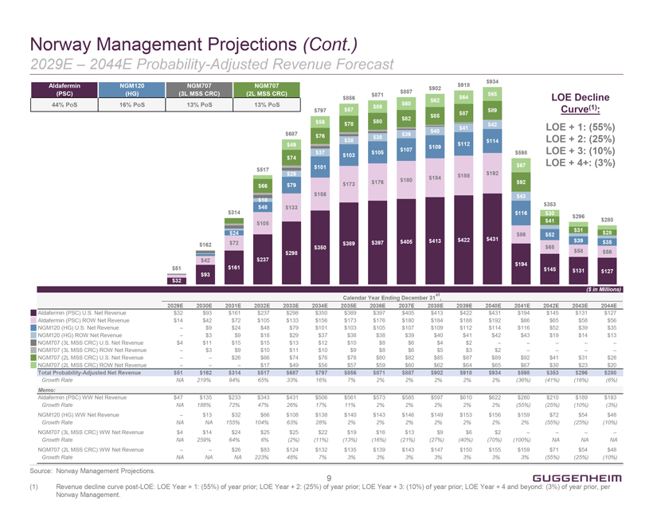
Norway Management Projections (Cont.) 2029E  2044E Probability-Adjusted Revenue Forecast Aldafermin (PSC) 44% PoS NGM120 (HG) 16% PoS NGM707 (3L MSS CRC) 13% PoS NGM707 (2L MSS CRC) 13% PoS $32 $51 $162 $42 $93 $314 $24 $72 $161 $517 $66 $18 $48 $105 $237 $687 $49 $74 $29 $79 $133 $298 $797 $56 $76 $37 $101 $156 $350 $856 $57 $78 $38 $103 $173 $389 $871 $59 $80 $38 $105 $176 $397 $887 $60 $82 $39 $107 $180 $405 $902 $62 $85 $40 $109 $184 $413 $918 $64 $87 $41 $112 $188 $422 $934 $65 $89 $42 $114 $192 $431 $598 $67 $92 $43 $116 $86 $194 $353 $30 $41 $52 $65 $145 $296 $31 $39 $58 $131 $280 $28 $35 $56 $127 LOE Decline Curve(1): LOE + 1: (55%) LOE + 2: (25%) LOE + 3: (10%) LOE + 4+: (3%) ($ in Millions) Calendar Year Ending December 31st , 2029E 2030E 2031E 2032E 2033E 2034E 2035E 2036E 2037E 2038E 2039E 2040E 2041E 2042E 2043E 2044E Aldafermin (PSC) U.S. Net Revenue $32 $93 $161 $237 $298 $350 $389 $397 $405 $413 $422 $431 $194 $145 $131 $127 Aldafermin (PSC) ROW Net Revenue $14 $42 $72 $105 $133 $156 $173 $176 $180 $184 $188 $192 $86 $65 $58 $56 NGM120 (HG) U.S. Net Revenue  $9 $24 $48 $79 $101 $103 $105 $107 $109 $112 $114 $116 $52 $39 $35 NGM120 (HG) ROW Net Revenue  $3 $9 $18 $29 $37 $38 $38 $39 $40 $41 $42 $43 $19 $14 $13 NGM707 (3L MSS CRC) U.S. Net Revenue $4 $11 $15 $15 $13 $12 $10 $8 $6 $4 $2      NGM707 (3L MSS CRC) ROW Net Revenue  $3 $9 $10 $11 $10 $9 $8 $6 $5 $3 $2     NGM707 (2L MSS CRC) U.S. Net Revenue   $26 $66 $74 $76 $78 $80 $82 $85 $87 $89 $92 $41 $31 $28 NGM707 (2L MSS CRC) ROW Net Revenue    $17 $49 $56 $57 $59 $60 $62 $64 $65 $67 $30 $23 $20 Total Probability-Adjusted Net Revenue $51 $162 $314 $517 $687 $797 $856 $871 $887 $902 $918 $934 $598 $353 $296 $280 Growth Rate NA 219% 94% 65% 33% 16% 7% 2% 2% 2% 2% 2% (36%) (41%) (16%) (6%) Memo: Aldafermin (PSC) WW Net Revenue $47 $135 $233 $343 $431 $506 $561 $573 $585 $597 $610 $622 $280 $210 $189 $183 Growth Rate NA 188% 72% 47% 26% 17% 11% 2% 2% 2% 2% 2% (55%) (25%) (10%) (3%) NGM120 (HG) WW Net Revenue  $13 $32 $66 $108 $138 $140 $143 $146 $149 $153 $156 $159 $72 $54 $48 Growth Rate NA NA 155% 104% 63% 28% 2% 2% 2% 2% 2% 2% 2% (55%) (25%) (10%) NGM707 (3L MSS CRC) WW Net Revenue $4 $14 $24 $25 $25 $22 $19 $16 $13 $9 $6 $2     Growth Rate NA 259% 64% 6% (2%) (11%) (13%) (16%) (21%) (27%) (40%) (70%) (100%) NA NA NA NGM707 (2L MSS CRC) WW Net Revenue   $26 $83 $124 $132 $135 $139 $143 $147 $150 $155 $159 $71 $54 $48 Growth Rate NA NA NA 223% 48% 7% 3% 3% 3% 3% 3% 3% 3% (55%) (25%) (10%) Source: Norway Management Projections. (1) Revenue decline curve post-LOE: LOE Year + 1: (55%) of year prior; LOE Year + 2: (25%) of year prior; LOE Year + 3: (10%) of year prior; LOE Year + 4 and beyond: (3%) of year prior, per Norway Management. 9 GUGGENHEIM

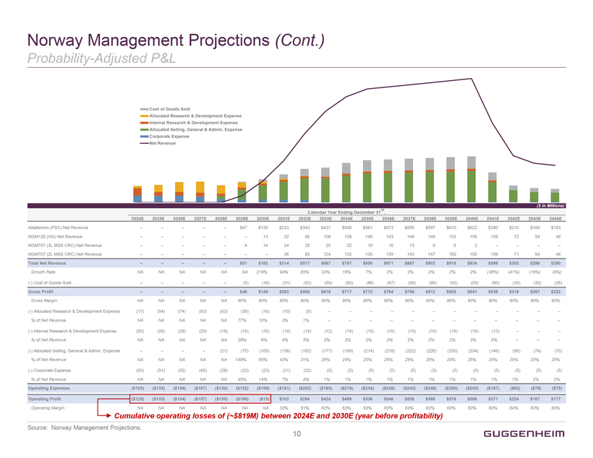
Norway Management Projections (Cont.) Probability-Adjusted P&L Cost of Goods Sold Allocated Research & Development Expense Internal Research & Development Expense Allocated Selling, General & Admin. Expense Corporate Expense Net Revenue ($ in Millions) Calendar Year Ending December 31st , 2024E 2025E 2026E 2027E 2028E 2029E 2030E 2031E 2032E 2033E 2034E 2035E 2036E 2037E 2038E 2039E 2040E 2041E 2042E 2043E 2044E Aldafermin (PSC) Net Revenue      $47 $135 $233 $343 $431 $506 $561 $573 $585 $597 $610 $622 $280 $210 $189 $183 NGM120 (HG) Net Revenue       13 32 66 108 138 140 143 146 149 153 156 159 72 54 48 NGM707 (3L MSS CRC) Net Revenue      4 14 24 25 25 22 19 16 13 9 6 2     NGM707 (2L MSS CRC) Net Revenue        26 83 124 132 135 139 143 147 150 155 159 71 54 48 Total Net Revenue      $51 $162 $314 $517 $687 $797 $856 $871 $887 $902 $918 $934 $598 $353 $296 $280 Growth Rate NA NA NA NA NA NA 219% 94% 65% 33% 16% 7% 2% 2% 2% 2% 2% (36%) (41%) (16%) (6%) (-) Cost of Goods Sold      (5) (16) (31) (52) (69) (80) (86) (87) (89) (90) (92) (93) (60) (35) (30) (28) Gross Profit      $46 $146 $283 $466 $618 $717 $770 $784 $798 $812 $826 $841 $538 $318 $267 $252 Gross Margin NA NA NA NA NA 90% 90% 90% 90% 90% 90% 90% 90% 90% 90% 90% 90% 90% 90% 90% 90% (-) Allocated Research & Development Expense (17) (54) (74) (83) (63) (39) (16) (10) (5)             % of Net Revenue NA NA NA NA NA 77% 10% 3% 1%             (-) Internal Research & Development Expense (55) (28) (28) (29) (18) (15) (15) (14) (14) (12) (14) (15) (15) (15) (15) (16) (16) (13)    % of Net Revenue NA NA NA NA NA 29% 9% 4% 3% 2% 2% 2% 2% 2% 2% 2% 2% 2%    (-) Allocated Selling, General & Admin. Expense     (21) (75) (105) (136) (162) (177) (199) (214) (218) (222) (226) (230) (234) (149) (88) (74) (70) % of Net Revenue NA NA NA NA NA 148% 65% 43% 31% 26% 25% 25% 25% 25% 25% 25% 25% 25% 25% 25% 25% (-) Corporate Expense (53) (51) (52) (45) (28) (23) (23) (21) (22) (5) (5) (5) (5) (5) (5) (5) (5) (5) (5) (5) (5) % of Net Revenue NA NA NA NA NA 45% 14% 7% 4% 1% 1% 1% 1% 1% 1% 1% 1% 1% 1% 2% 2% Operating Expenses ($125) ($133) ($154) ($157) ($130) ($152) ($159) ($181) ($202) ($195) ($219) ($234) ($238) ($242) ($246) ($250) ($255) ($167) ($93) ($79) ($75) Operating Profit ($125) ($133) ($154) ($157) ($130) ($106) ($13) $102 $264 $424 $499 $536 $546 $556 $566 $576 $586 $371 $224 $187 $177 Operating Margin NA NA NA NA NA NA NA 33% 51% 62% 63% 63% 63% 63% 63% 63% 63% 62% 64% 63% 63% Cumulative operating losses of (~$819M) between 2024E and 2030E (year before profitability) Source: Norway Management Projections. 10 GUGGENHEIM

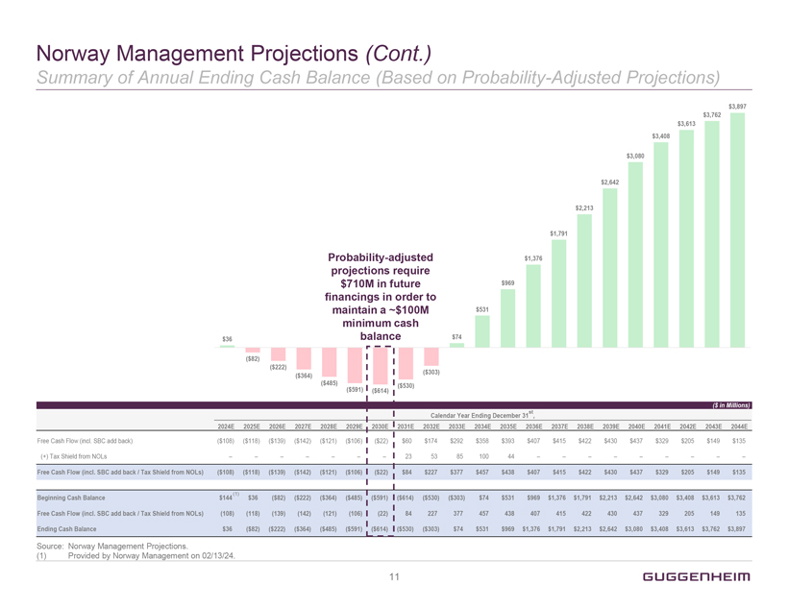
Norway Management Projections (Cont.) Summary of Annual Ending Cash Balance (Based on Probability-Adjusted Projections) Probability-adjusted projections require $710M in future financings in order to maintain a ~$100M minimum cash balance $36 ($82) ($222) ($364) ($485) ($591) ($614) ($530) ($303) $74 $531 $969 $1,376 $1,791 $2,213 $2,642 $3,080 $3,408 $3,613 $3,762 $3,897 ($ in Millions) Calendar Year Ending December 31st, 2024E 2025E 2026E 2027E 2028E 2029E 2030E 2031E 2032E 2033E 2034E 2035E 2036E 2037E 2038E 2039E 2040E 2041E 2042E 2043E 2044E Free Cash Flow (incl. SBC add back) ($108) ($118) ($139) ($142) ($121) ($106) ($22) $60 $174 $292 $358 $393 $407 $415 $422 $430 $437 $329 $205 $149 $135 (+) Tax Shield from NOLs        23 53 85 100 44          Free Cash Flow (incl. SBC add back / Tax Shield from NOLs) ($108) ($118) ($139) ($142) ($121) ($106) ($22) $84 $227 $377 $457 $438 $407 $415 $422 $430 $437 $329 $205 $149 $135 Beginning Cash Balance $144(1) $36 ($82) ($222) ($364) ($485) ($591) ($614) ($530) ($303) $74 $531 $969 $1,376 $1,791 $2,213 $2,642 $3,080 $3,408 $3,613 $3,762 Free Cash Flow (incl. SBC add back / Tax Shield from NOLs) (108) (118) (139) (142) (121) (106) (22) 84 227 377 457 438 407 415 422 430 437 329 205 149 135 Ending Cash Balance $36 ($82) ($222) ($364) ($485) ($591) ($614) ($530) ($303) $74 $531 $969 $1,376 $1,791 $2,213 $2,642 $3,080 $3,408 $3,613 $3,762 $3,897 Source: Norway Management Projections. (1) Provided by Norway Management on 02/13/24. 11 GUGGENHEIM

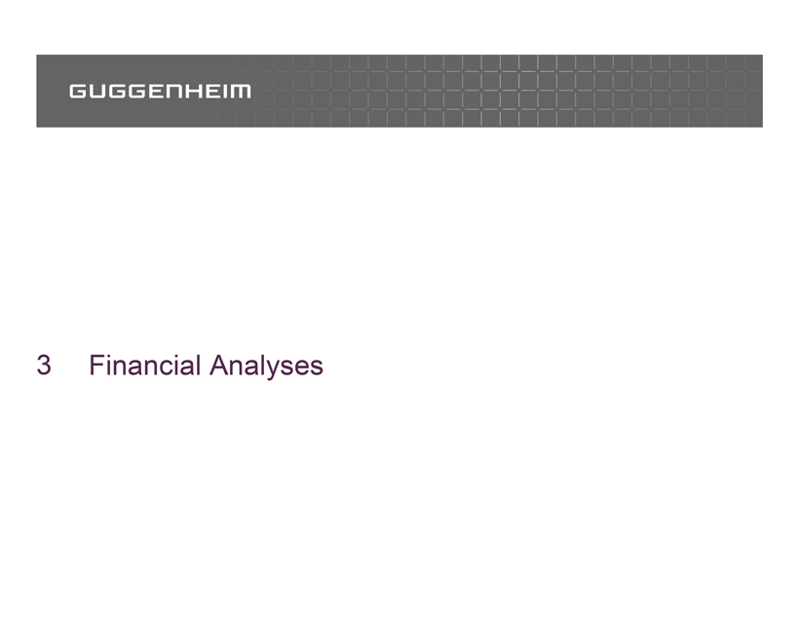
GUGGENHEIM 3 Financial Analyses

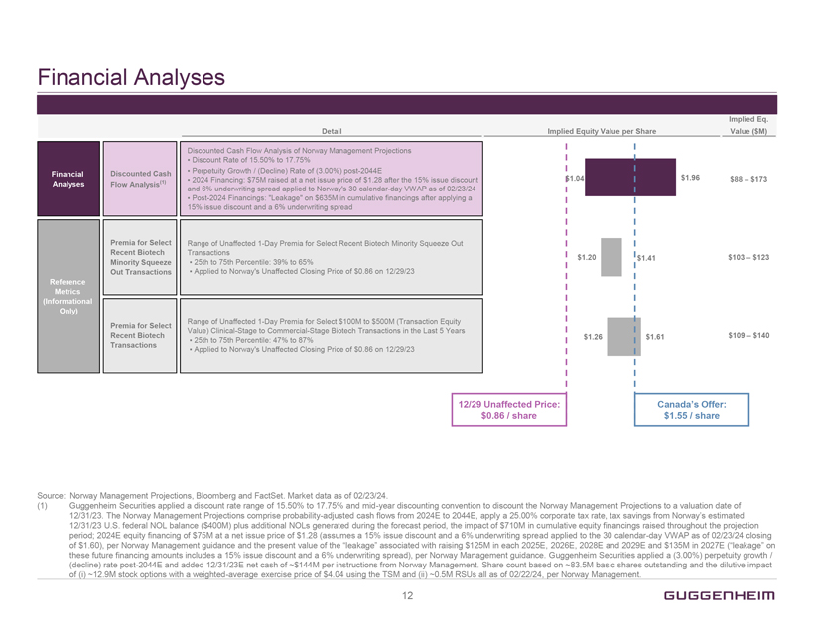
Financial Analyses Detail Financial Analyses Discounted Cash Flow Analysis(1) Discounted Cash Flow Analysis of Norway Management Projections Discount Rate of 15.50% to 17.75% Perpetuity Growth / (Decline) Rate of (3.00%) post-2044E 2024 Financing: $75M raised at a net issue price of $1.28 after the 15% issue discount and 6% underwriting spread applied to Norways 30 calendar-day VWAP as of 02/23/24 Post-2024 Financings: Leakage on $635M in cumulative financings after applying a 15% issue discount and a 6% underwriting spread Reference Metrics (Informational Only) Premia for Select Recent Biotech Minority Squeeze Out Transactions Range of Unaffected 1-Day Premia for Select Recent Biotech Minority Squeeze Out Transactions 25th to 75th Percentile: 39% to 65% Applied to Norways Unaffected Closing Price of $0.86 on 12/29/23 Premia for Select Recent Biotech Transactions Range of Unaffected 1-Day Premia for Select $100M to $500M (Transaction Equity Value) Clinical-Stage to Commercial-Stage Biotech Transactions in the Last 5 Years 25th to 75th Percentile: 47% to 87% Applied to Norways Unaffected Closing Price of $0.86 on 12/29/23 Implied Equity Value per Share 1.04 $1.20 $1.26 12/29 Unaffected Price: $0.86 / share $1.96 $1.41 $1.61 Canadas Offer: $1.55 / share Implied Eq. Value ($M) $88  $173 $103  $123 $109  $140 Canadas Offer: $1.55 / share Source: Norway Management Projections, Bloomberg and FactSet. Market data as of 02/23/24. (1) Guggenheim Securities applied a discount rate range of 15.50% to 17.75% and mid-year discounting convention to discount the Norway Management Projections to a valuation date of 12/31/23. The Norway Management Projections comprise probability-adjusted cash flows from 2024E to 2044E, apply a 25.00% corporate tax rate, tax savings from Norways estimated 12/31/23 U.S. federal NOL balance ($400M) plus additional NOLs generated during the forecast period, the impact of $710M in cumulative equity financings raised throughout the projection period; 2024E equity financing of $75M at a net issue price of $1.28 (assumes a 15% issue discount and a 6% underwriting spread applied to the 30 calendar-day VWAP as of 02/23/24 closing of $1.60), per Norway Management guidance and the present value of the leakage associated with raising $125M in each 2025E,2026E, 2028E and 2029E and $135M in 2027E (leakage on these future financing amounts includes a 15% issue discount and a 6% underwriting spread), per Norway Management guidance. Guggenheim Securities applied a (3.00%) perpetuity growth / (decline) rate post-2044E and added 12/31/23E net cash of ~$144M per instructions from Norway Management. Share count based on ~83.5M basic shares outstanding and the dilutive impact of (i) ~12.9M stock options with a weighted-average exercise price of $4.04 using the TSM and (ii) ~0.5M RSUs all as of 02/22/24, per Norway Management. 12 GUGGENHEIM

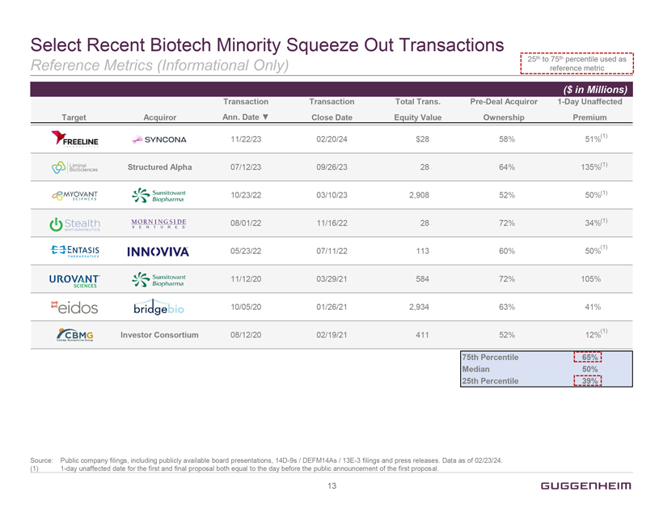
Select Recent Biotech Minority Squeeze Out Transactions Reference Metrics (Informational Only) 25th to 75th percentile used as reference metric ($ in Millions) Target Acquiror Transaction Ann. Date Transaction Close Date Total Trans. Equity Value Pre-Deal Acquiror Ownership 1-Day Unaffected Premium FREELINE SYNCONA 11/22/23 02/20/24 $28 58% 51%(1) Liminal BioSciences Structured Alpha 07/12/23 09/26/23 28 64% 135%(1) MYOVANT SCIENCES Sumitovant Biopharma 10/23/22 03/10/23 2,908 52% 50%(1) Stealth BIOTHERAPEUTICS MORNINGSIDE VENTURES 08/01/22 11/16/22 28 72% 34%(1) ENTASIS THERAPEUTICS INNOVIVA 05/23/22 07/11/22 113 60% 50%(1) UROVANT SCIENCES Sumitovant Biopharma 11/12/20 03/29/21 584 72% 105% eidos bridgebio 10/05/20 01/26/21 2,934 63% 41% CBMS Cellular Biomedicine Group Investor Consortium 08/12/20 02/19/21 411 12%(1) Source: Public company filings, including publicly available board presentations, 14D-9s / DEFM14As / 13E-3 filings and press releases. Data as of 02/23/24. (1)1-day unaffected date for the first and final proposal both equal to the day before the public announcement of the first proposal. 13 GUGGENHEIM

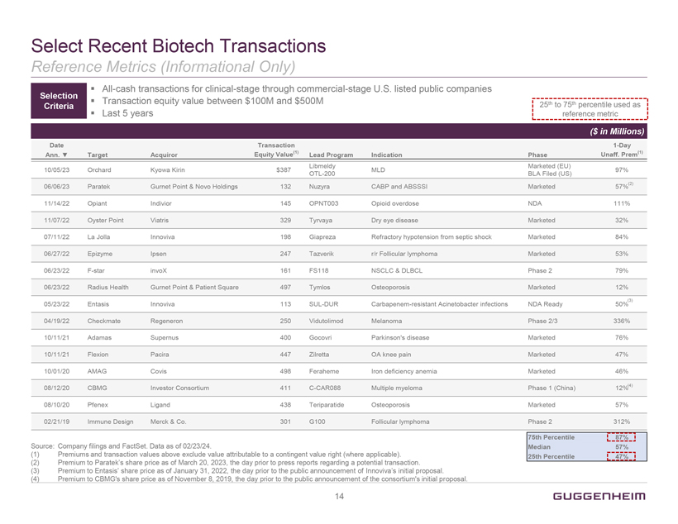
Select Recent Biotech Transactions Reference Metrics (Informational Only) Selection Criteria All-cash transactions for clinical-stage through commercial-stage U.S. listed public companies Transaction equity value between $100M and $500M Last 5 years 25th to 75th percentile used as reference metric ($ in Millions) Date Ann. Target Acquiror Transaction Equity Value(1) Lead Program Indication Phase 1-Day Unaff. Prem(1) Libmeldy Marketed (EU) 10/05/23 Orchard Kyowa Kirin $387 MLD 97% OTL-200 BLA Filed (US) 06/06/23 Paratek Gurnet Point & Novo Holdings 132 Nuzyra CABP and ABSSSI Marketed 57%(2) 11/14/22 Opiant Indivior 145 OPNT003 Opioid overdose NDA 111% 11/07/22 Oyster Point Viatris 329 Tyrvaya Dry eye disease Marketed 32% 07/11/22 La Jolla Innoviva 198 Giapreza Refractory hypotension from septic shock Marketed 84% 06/27/22 Epizyme Ipsen 247 Tazverik r/r Follicular lymphoma Marketed 53% 06/23/22 F-star invoX 161 FS118 NSCLC & DLBCL Phase 2 79% 06/23/22 Radius Health Gurnet Point & Patient Square 497 Tymlos Osteoporosis Marketed 12% 05/23/22 Entasis Innoviva 113 SUL-DUR Carbapenem-resistant Acinetobacter infections NDA Ready 50%(3) 04/19/22 Checkmate Regeneron 250 Vidutolimod Melanoma Phase 2/3 336% 10/11/21 Adamas Supernus 400 Gocovri Parkinsons disease Marketed 76% 10/11/21 Flexion Pacira 447 Zilretta OA knee pain Marketed 47% 10/01/20 AMAG Covis 498 Feraheme Iron deficiency anemia Marketed 46% 08/12/20 CBMG Investor Consortium 411 C-CAR088 Multiple myeloma Phase 1 (China) 12%(4) 08/10/20 Pfenex Ligand 438 Teriparatide Osteoporosis Marketed 57% 02/21/19 Immune Design Merck & Co. 301 G100 Follicular lymphoma Phase 2 312% 75th Percentile 87% Median 57% 25th Percentile 47% Source: Company filings and FactSet. Data as of 02/23/24. (1) Premiums and transaction values above exclude value attributable to a contingent value right (where applicable). (2) Premium to Parateks share price as of March 20, 2023, the day prior to press reports regarding a potential transaction. (3) Premium to Entasis share price as of January 31, 2022, the day prior to the public announcement of Innovivas initial proposal. (4) Premium to CBMGs share price as of November 8, 2019, the day prior to the public announcement of the consortiums initial proposal. 14 GUGGENHEIM

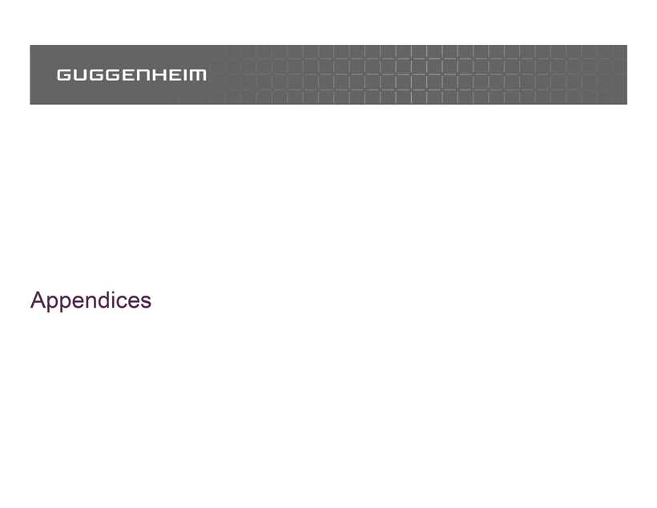
GUGGENHEIM Appendices

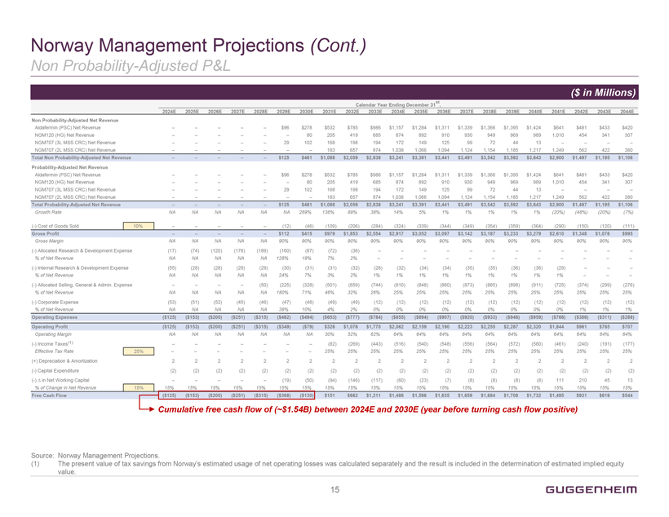
Norway Management Projections (Cont.) Non Probability-Adjusted P&L ($ in Millions) Calendar Year Ending December 31st , 2024E 2025E 2026E 2027E 2028E 2029E 2030E 2031E 2032E 2033E 2034E 2035E 2036E 2037E 2038E 2039E 2040E 2041E 2042E 2043E 2044E Non Probability-Adjusted Net Revenue Aldafermin (PSC) Net Revenue      $96 $278 $532 $785 $986 $1,157 $1,284 $1,311 $1,339 $1,366 $1,395 $1,424 $641 $481 $433 $420 NGM120 (HG) Net Revenue       80 205 419 685 874 892 910 930 949 969 989 1,010 454 341 307 NGM707 (3L MSS CRC) Net Revenue      29 102 168 198 194 172 149 125 99 72 44 13     NGM707 (2L MSS CRC) Net Revenue        183 657 974 1,038 1,066 1,094 1,124 1,154 1,185 1,217 1,249 562 422 380 Total Non Probability-Adjusted Net Revenue      $125 $461 $1,088 $2,059 $2,838 $3,241 $3,391 $3,441 $3,491 $3,542 $3,592 $3,643 $2,900 $1,497 $1,195 $1,106 Probability-Adjusted Net Revenue Aldafermin (PSC) Net Revenue      $96 $278 $532 $785 $986 $1,157 $1,284 $1,311 $1,339 $1,366 $1,395 $1,424 $641 $481 $433 $420 NGM120 (HG) Net Revenue       80 205 419 685 874 892 910 930 949 969 989 1,010 454 341 307 NGM707 (3L MSS CRC) Net Revenue      29 102 168 198 194 172 149 125 99 72 44 13     NGM707 (2L MSS CRC) Net Revenue        183 657 974 1,038 1,066 1,094 1,124 1,154 1,185 1,217 1,249 562 422 380 Total Probability-Adjusted Net Revenue      $125 $461 $1,088 $2,059 $2,838 $3,241 $3,391 $3,441 $3,491 $3,542 $3,592 $3,643 $2,900 $1,497 $1,195 $1,106 Growth Rate NA NA NA NA NA NA 269% 136% 89% 38% 14% 5% 1% 1% 1% 1% 1% (20%) (48%) (20%) (7%) (-) Cost of Goods Sold 10%      (12) (46) (109) (206) (284) (324) (339) (344) (349) (354) (359) (364) (290) (150) (120) (111) Gross Profit      $112 $415 $979 $1,853 $2,554 $2,917 $3,052 $3,097 $3,142 $3,187 $3,233 $3,279 $2,610 $1,348 $1,076 $995 Gross Margin NA NA NA NA NA 90% 90% 90% 90% 90% 90% 90% 90% 90% 90% 90% 90% 90% 90% 90% 90% (-) Allocated Research & Development Expense (17) (74) (120) (176) (189) (160) (87) (72) (36)             % of Net Revenue NA NA NA NA NA 128% 19% 7% 2%             (-) Internal Research & Development Expense (55) (28) (28) (29) (29) (30) (31) (31) (32) (28) (32) (34) (34) (35) (35) (36) (36) (29)    % of Net Revenue NA NA NA NA NA 24% 7% 3% 2% 1% 1% 1% 1% 1% 1% 1% 1% 1%    (-) Allocated Selling, General & Admin. Expense     (50) (225) (328) (501) (659) (744) (810) (848) (860) (873) (885) (898) (911) (725) (374) (299) (276) % of Net Revenue NA NA NA NA NA 180% 71% 46% 32% 26% 25% 25% 25% 25% 25% 25% 25% 25% 25% 25% 25% (-) Corporate Expense (53) (51) (52) (45) (46) (47) (48) (49) (49) (12) (12) (12) (12) (12) (12) (12) (12) (12) (12) (12) (12) % of Net Revenue NA NA NA NA NA 38% 10% 4% 2% 0% 0% 0% 0% 0% 0% 0% 0% 0% 1% 1% 1% Operating Expenses ($125) ($153) ($200) ($251) ($315) ($462) ($494) ($653) ($777) ($784) ($855) ($894) ($907) ($920) ($933) ($946) ($959) ($766) ($386) ($311) ($288) Operating Profit ($125) ($153) ($200) ($251) ($315) ($349) ($79) $326 $1,076 $1,770 $2,062 $2,159 $2,190 $2,223 $2,255 $2,287 $2,320 $1,844 $961 $765 $707 Operating Margin NA NA NA NA NA NA NA 30% 52% 62% 64% 64% 64% 64% 64% 64% 64% 64% 64% 64% 64% (-) Income Taxes(1)        (82) (269) (443) (516) (540) (548) (556) (564) (572) (580) (461) (240) (191) (177) Effective Tax Rate 25%        25% 25% 25% 25% 25% 25% 25% 25% 25% 25% 25% 25% 25% 25% (+) Depreciation & Amortization 2 2 2 2 2 2 2 2 2 2 2 2 2 2 2 2 2 2 2 2 2 (-) Capital Expenditure (2) (2) (2) (2) (2) (2) (2) (2) (2) (2) (2) (2) (2) (2) (2) (2) (2) (2) (2) (2) (2) (-) in Net Working Capital      (19) (50) (94) (146) (117) (60) (23) (7) (8) (8) (8) (8) 111 210 45 13 % of Change in Net Revenue 15% 15% 15% 15% 15% 15% 15% 15% 15% 15% 15% 15% 15% 15% 15% 15% 15% 15% 15% 15% 15% 15% Free Cash Flow ($125) ($153) ($200) ($251) ($315) ($368) ($130) $151 $662 $1,211 $1,486 $1,596 $1,635 $1,659 $1,684 $1,708 $1,732 $1,495 $931 $619 $544 Cumulative free cash flow of (~$1.54B) between 2024E and 2030E (year before turning cash flow positive) Source: Norway Management Projections. (1) The present value of tax savings from Norways estimated usage of net operating losses was calculated separately and the result is included in the determination of estimated implied equity value. 15 GUGGENHEIM

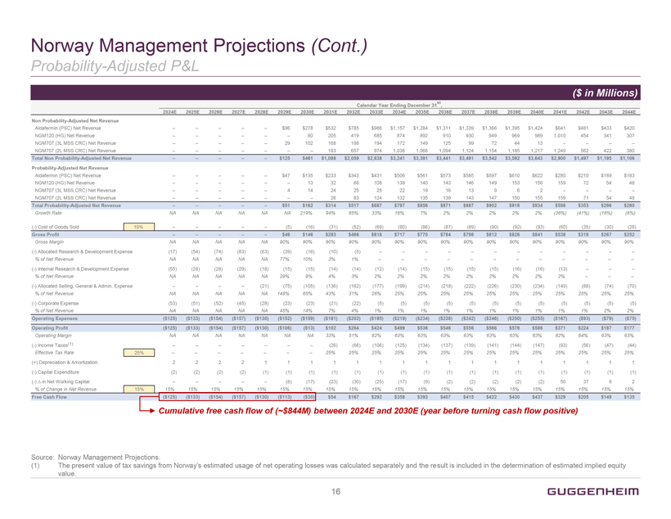
Norway Management Projections (Cont.) Probability-Adjusted P&L ($ in Millions) Calendar Year Ending December 31st , 2024E 2025E 2026E 2027E 2028E 2029E 2030E 2031E 2032E 2033E 2034E 2035E 2036E 2037E 2038E 2039E 2040E 2041E 2042E 2043E 2044E Non Probability-Adjusted Net Revenue Aldafermin (PSC) Net Revenue      $96 $278 $532 $785 $986 $1,157 $1,284 $1,311 $1,339 $1,366 $1,395 $1,424 $641 $481 $433 $420 NGM120 (HG) Net Revenue       80 205 419 685 874 892 910 930 949 969 989 1,010 454 341 307 NGM707 (3L MSS CRC) Net Revenue      29 102 168 198 194 172 149 125 99 72 44 13     NGM707 (2L MSS CRC) Net Revenue        183 657 974 1,038 1,066 1,094 1,124 1,154 1,185 1,217 1,249 562 422 380 Total Non Probability-Adjusted Net Revenue      $125 $461 $1,088 $2,059 $2,838 $3,241 $3,391 $3,441 $3,491 $3,542 $3,592 $3,643 $2,900 $1,497 $1,195 $1,106 Probability-Adjusted Net Revenue Aldafermin (PSC) Net Revenue      $47 $135 $233 $343 $431 $506 $561 $573 $585 $597 $610 $622 $280 $210 $189 $183 NGM120 (HG) Net Revenue       13 32 66 108 138 140 143 146 149 153 156 159 72 54 48 NGM707 (3L MSS CRC) Net Revenue      4 14 24 25 25 22 19 16 13 9 6 2     NGM707 (2L MSS CRC) Net Revenue        26 83 124 132 135 139 143 147 150 155 159 71 54 48 Total Probability-Adjusted Net Revenue      $51 $162 $314 $517 $687 $797 $856 $871 $887 $902 $918 $934 $598 $353 $296 $280 Growth Rate NA NA NA NA NA NA 219% 94% 65% 33% 16% 7% 2% 2% 2% 2% 2% (36%) (41%) (16%) (6%) (-) Cost of Goods Sold 10%      (5) (16) (31) (52) (69) (80) (86) (87) (89) (90) (92) (93) (60) (35) (30) (28) Gross Profit      $46 $146 $283 $466 $618 $717 $770 $784 $798 $812 $826 $841 $538 $318 $267 $252 Gross Margin NA NA NA NA NA 90% 90% 90% 90% 90% 90% 90% 90% 90% 90% 90% 90% 90% 90% 90% 90% (-) Allocated Research & Development Expense (17) (54) (74) (83) (63) (39) (16) (10) (5)             % of Net Revenue NA NA NA NA NA 77% 10% 3% 1%             (-) Internal Research & Development Expense (55) (28) (28) (29) (18) (15) (15) (14) (14) (12) (14) (15) (15) (15) (15) (16) (16) (13)    % of Net Revenue NA NA NA NA NA 29% 9% 4% 3% 2% 2% 2% 2% 2% 2% 2% 2% 2%    (-) Allocated Selling, General & Admin. Expense     (21) (75) (105) (136) (162) (177) (199) (214) (218) (222) (226) (230) (234) (149) (88) (74) (70) % of Net Revenue NA NA NA NA NA 148% 65% 43% 31% 26% 25% 25% 25% 25% 25% 25% 25% 25% 25% 25% 25% (-) Corporate Expense (53) (51) (52) (45) (28) (23) (23) (21) (22) (5) (5) (5) (5) (5) (5) (5) (5) (5) (5) (5) (5) % of Net Revenue NA NA NA NA NA 45% 14% 7% 4% 1% 1% 1% 1% 1% 1% 1% 1% 1% 1% 2% 2% Operating Expenses ($125) ($133) ($154) ($157) ($130) ($152) ($159) ($181) ($202) ($195) ($219) ($234) ($238) ($242) ($246) ($250) ($255) ($167) ($93) ($79) ($75) Operating Profit ($125) ($133) ($154) ($157) ($130) ($106) ($13) $102 $264 $424 $499 $536 $546 $556 $566 $576 $586 $371 $224 $187 $177 Operating Margin NA NA NA NA NA NA NA 33% 51% 62% 63% 63% 63% 63% 63% 63% 63% 62% 64% 63% 63% (-) Income Taxes(1)        (26) (66) (106) (125) (134) (137) (139) (141) (144) (147) (93) (56) (47) (44) Effective Tax Rate 25%        25% 25% 25% 25% 25% 25% 25% 25% 25% 25% 25% 25% 25% 25% (+) Depreciation & Amortization 2 2 2 2 1 1 1 1 1 1 1 1 1 1 1 1 1 1 1 1 1 (-) Capital Expenditure (2) (2) (2) (2) (1) (1) (1) (1) (1) (1) (1) (1) (1) (1) (1) (1) (1) (1) (1) (1) (1) (-) in Net Working Capital      (8) (17) (23) (30) (25) (17) (9) (2) (2) (2) (2) (2) 50 37 9 2 % of Change in Net Revenue 15% 15% 15% 15% 15% 15% 15% 15% 15% 15% 15% 15% 15% 15% 15% 15% 15% 15% 15% 15% 15% 15% Free Cash Flow ($125) ($133) ($154) ($157) ($130) ($113) ($30) $54 $167 $292 $358 $393 $407 $415 $422 $430 $437 $329 $205 $149 $135 Cumulative free cash flow of (~$844M) between 2024E and 2030E (year before turning cash flow positive) Source: Norway Management Projections. (1) The present value of tax savings from Norways estimated usage of net operating losses was calculated separately and the result is included in the determination of estimated implied equity value. 16 GUGGENHEIM

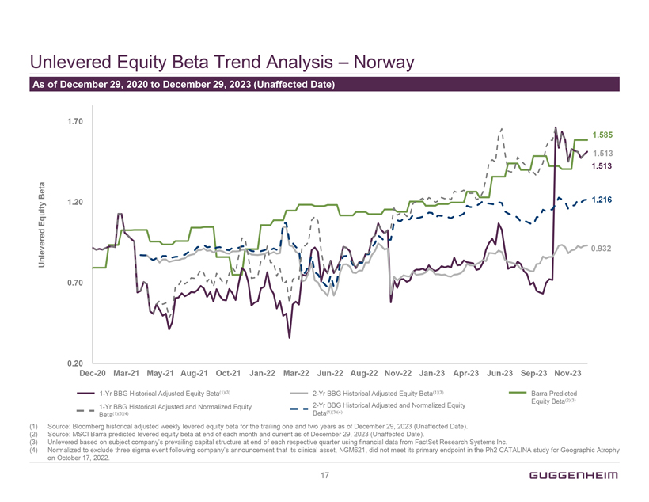
Unlevered Equity Beta Trend Analysis  Norway As of December 29, 2020 to December 29, 2023 (Unaffected Date) Dec-20 Mar-21 May-21 Aug-21 Oct-21 Jan-22 Mar-22 Jun-22 Aug-22 Nov-22 Jan-23 Apr-23 Jun-23 Sep-23 Nov-23 Unlevered Equity Beta 1.70 1.20 0.70 0.20 1.585 1.513 1.513 1.216 0.932 1-Yr BBG Historical Adjusted Equity Beta(1)(3) 2-Yr BBG Historical Adjusted Equity Beta(1)(3) Barra Predicted Beta(2)(3) 1-Yr BBG Historical Adjusted and Normalized Equity Beta(1)(3)(4) 2-Yr BBG Historical Adjusted and Normalized Equity Equity Beta(1)(3)(4) (1) Source: Bloomberg historical adjusted weekly levered equity beta for the trailing one and two years as of December 29, 2023 (Unaffected Date). (2) Source: MSCI Barra predicted levered equity beta at end of each month and current as of December 29, 2023 (Unaffected Date). (3) Unlevered based on subject companys prevailing capital structure at end of each respective quarter using financial data from FactSet Research Systems Inc. (4) Normalized to exclude three sigma event following companys announcement that its clinical asset, NGM621, did not meet its primary endpoint in the Ph2 CATALINA study for Geographic Atrophy on October 17, 2022. 17 GUGGENHEIM

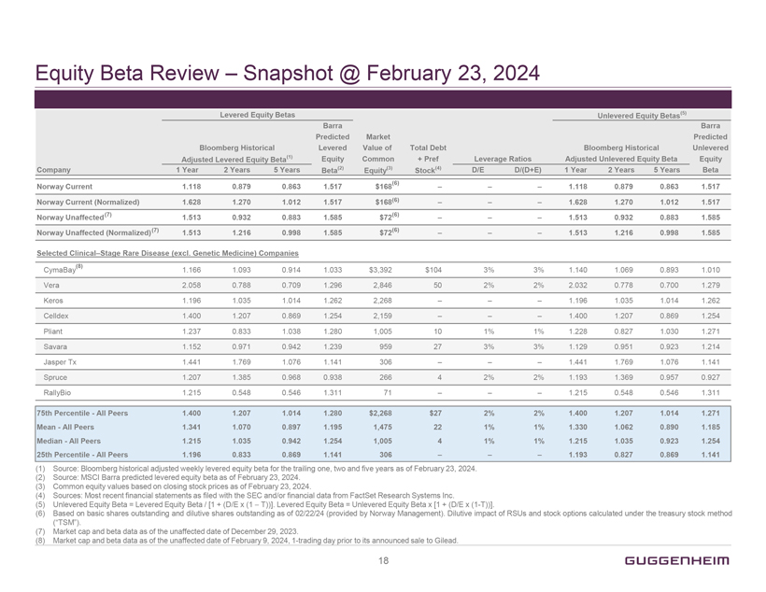
Equity Beta Review  Snapshot @ February 23, 2024 Levered Equity Betas Unlevered Equity Betas(5) Barra Barra Predicted Market Predicted Bloomberg Historical Levered Value of Total Debt Bloomberg Historical Unlevered Adjusted Levered Equity Beta(1) Equity Common + Pref Leverage Ratios Adjusted Unlevered Equity Beta Equity Company 1 Year 2 Years 5 Years Beta(2) Equity(3) Stock(4) D/E D/(D+E) 1 Year 2 Years 5 Years Beta Norway Current 1.118 0.879 0.863 1.517 $168(6)    1.118 0.879 0.863 1.517 Norway Current (Normalized) 1.628 1.270 1.012 1.517 $168(6)    1.628 1.270 1.012 1.517 Norway Unaffected (7) 1.513 0.932 0.883 1.585 $72(6)    1.513 0.932 0.883 1.585 Norway Unaffected (Normalized)(7) 1.513 1.216 0.998 1.585 $72(6)    1.513 1.216 0.998 1.585 Selected ClinicalStage Rare Disease (excl. Genetic Medicine) Companies CymaBay(8) 1.166 1.093 0.914 1.033 $3,392 $104 3% 3% 1.140 1.069 0.893 1.010 Vera 2.058 0.788 0.709 1.296 2,846 50 2% 2% 2.032 0.778 0.700 1.279 Keros 1.196 1.035 1.014 1.262 2,268    1.196 1.035 1.014 1.262 Celldex 1.400 1.207 0.869 1.254 2,159    1.400 1.207 0.869 1.254 Pliant 1.237 0.833 1.038 1.280 1,005 10 1% 1% 1.228 0.827 1.030 1.271 Savara 1.152 0.971 0.942 1.239 959 27 3% 3% 1.129 0.951 0.923 1.214 Jasper Tx 1.441 1.769 1.076 1.141 306    1.441 1.769 1.076 1.141 Spruce 1.207 1.385 0.968 0.938 266 4 2% 2% 1.193 1.369 0.957 0.927 RallyBio 1.215 0.548 0.546 1.311 71    1.215 0.548 0.546 1.311 75th PercentileAll Peers 1.400 1.207 1.014 1.280 $2,268 $27 2% 2% 1.400 1.207 1.014 1.271 MeanAll Peers 1.341 1.070 0.897 1.195 1,475 22 1% 1% 1.330 1.062 0.890 1.185 MedianAll Peers 1.215 1.035 0.942 1.254 1,005 4 1% 1% 1.215 1.035 0.923 1.254 25th PercentileAll Peers 1.196 0.833 0.869 1.141 306    1.193 0.827 0.869 1.141 (1) Source: Bloomberg historical adjusted weekly levered equity beta for the trailing one, two and five years as of February 23, 2024. (2) Source: MSCI Barra predicted levered equity beta as of February 23, 2024. (3) Common equity values based on closing stock prices as of February 23, 2024. (4) Sources: Most recent financial statements as filed with the SEC and/or financial data from FactSet Research Systems Inc. (5) Unlevered Equity Beta = Levered Equity Beta / [1 + (D/E x (1 - T))]. Levered Equity Beta = Unlevered Equity Beta x [1 + (D/E x (1-T))]. (6) Based on basic shares outstanding and dilutive shares outstanding as of 02/22/24 (provided by Norway Management). Dilutive impact of RSUs and stock options calculated under the treasury stock method (TSM). (7) Market cap and beta data as of the unaffected date of December 29, 2023. (8) Market cap and beta data as of the unaffected date of February 9, 2024, 1-trading day prior to its announced sale to Gilead. 18 GUGGENHEIM

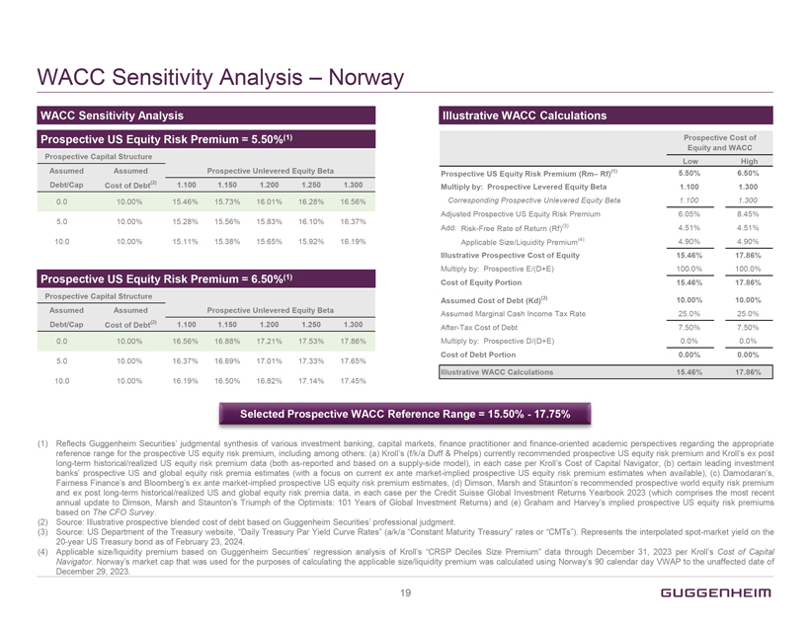
WACC Sensitivity Analysis  Norway WACC Sensitivity Analysis Prospective US Equity Risk Premium = 5.50%(1) Prospective Capital Structure Assumed Assumed Prospective Unlevered Equity Beta Debt/Cap Cost of Debt(2) 1.100 1.150 1.200 1.250 1.300 0.0 10.00% 15.46% 15.73% 16.01% 16.28% 16.56% 5.0 10.00% 15.28% 15.56% 15.83% 16.10% 16.37% 10.0 10.00% 15.11% 15.38% 15.65% 15.92% 16.19% Prospective US Equity Risk Premium = 6.50%(1) Prospective Capital Structure Assumed Assumed Prospective Unlevered Equity Beta Debt/Cap Cost of Debt(2) 1.100 1.150 1.200 1.250 1.300 0.0 10.00% 16.56% 16.88% 17.21% 17.53% 17.86% 5.0 10.00% 16.37% 16.69% 17.01% 17.33% 17.65% 10.0 10.00% 16.19% 16.50% 16.82% 17.14% 17.45% Illustrative WACC Calculations Prospective Cost of Equity and WACC Low High Prospective US Equity Risk Premium (Rm Rf)(1) 5.50% 6.50% Multiply by: Prospective Levered Equity Beta 1.100 1.300 Corresponding Prospective Unlevered Equity Beta 1.100 1.300 Adjusted Prospective US Equity Risk Premium 6.05% 8.45% Add: Risk-Free Rate of Return (Rf)(3) 4.51% 4.51% Applicable Size/Liquidity Premium(4) 4.90% 4.90% Illustrative Prospective Cost of Equity 15.46% 17.86% Multiply by: Prospective E/(D+E) 100.0% 100.0% Cost of Equity Portion 15.46% 17.86% Assumed Cost of Debt (Kd)(2) 10.00% 10.00% Assumed Marginal Cash Income Tax Rate 25.0% 25.0% After-Tax Cost of Debt 7.50% 7.50% Multiply by: Prospective D/(D+E) 0.0% 0.0% Cost of Debt Portion 0.00% 0.00% Illustrative WACC Calculations 15.46% 17.86% Selected Prospective WACC Reference Range = 15.50%17.75% (1) Reflects Guggenheim Securities judgmental synthesis of various investment banking, capital markets, finance practitioner and finance-oriented academic perspectives regarding the appropriate reference range for the prospective US equity risk premium, including among others: (a) Krolls (f/k/a Duff & Phelps) currently recommended prospective US equity risk premium and Krolls ex post long-term historical/realized US equity risk premium data (both as-reported and based on a supply-side model), in each case per Krolls Cost of Capital Navigator, (b) certain leading investment banks prospective US and global equity risk premia estimates (with a focus on current ex ante market-implied prospective US equity risk premium estimates when available), (c) Damodarans, Fairness Finances and Bloombergs ex ante market-implied prospective US equity risk premium estimates, (d) Dimson, Marsh and Stauntons recommended prospective world equity risk premium and ex post long-term historical/realized US and global equity risk premia data, in each case per the Credit Suisse Global Investment Returns Yearbook 2023 (which comprises the most recent annual update to Dimson, Marsh and Stauntons Triumph of the Optimists: 101 Years of Global Investment Returns) and (e) Graham and Harveys implied prospective US equity risk premiums based on The CFO Survey. (2) Source: Illustrative prospective blended cost of debt based on Guggenheim Securities professional judgment. (3) Source: US Department of the Treasury website, Daily Treasury Par Yield Curve Rates (a/k/a Constant Maturity Treasury rates or CMTs). Represents the interpolated spot-market yield on the 20-year US Treasury bond as of February 23, 2024. (4) Applicable size/liquidity premium based on Guggenheim Securities regression analysis of Krolls CRSP Deciles Size Premium data through December 31, 2023 per Krolls Cost of Capital Navigator. Norways market cap that was used for the purposes of calculating the applicable size/liquidity premium was calculated using Norways 90 calendar day VWAP to the unaffected date of December 29, 2023. 19 GUGGENHEIM
Exhibit (d)(2)


NON-DISCLOSURE AGREEMENT
This Non-Disclosure Agreement (Agreement), effective as of October 31, 2023 (Effective Date), is entered into by and between NGM Biopharmaceuticals, Inc., a Delaware corporation (Discloser) and The Column Group LLC (Recipient). Under this Agreement, Discloser may furnish certain of its confidential information to Counterparty in connection with the Counterpartys evaluation of Discloser (Purpose) upon the terms and conditions set forth below.
1. Confidential Information. Confidential Information means information about, or the existence of this Agreement and/or any potential business relationship between the parties and all information furnished by Discloser or its Representatives (as defined below) to Recipient or its Representatives, whether disclosed or provided in oral, written, graphic, electronic, photographic or any other tangible form, including, without limitation: (a) data, know-how, trade secrets and other intellectual property; (b) information relating to research, products and product candidates, assays, clinical and regulatory affairs, technology, manufacturing (including without limitation manufacturing methods and cell lines), finances and forecasts, business and contractual relationships, employees and other business information; and (c) analyses, compilations, studies or other materials prepared by Recipient or its Representatives containing or based, in whole or in part, upon information that Discloser or its Representatives furnished to Recipient or its Representatives. Confidential Information shall not include information that Recipient can demonstrate through competent written documentation: (i) was in Recipients or its Representatives possession before receipt from Discloser or its Representatives; (ii) is or becomes available to the public through no fault, act or omission of Recipient or its Representatives; (iii) is furnished to Recipient or its Representatives by a third party under no obligation of confidentiality and with the right to make such disclosure without restriction; or (iv) was or is independently discovered or developed by Recipient or its Representatives without reference to or use of Confidential Information. Any combination of features or disclosures shall not be deemed to fall within the foregoing exclusions merely because certain individual features fall within such foregoing exclusions unless the combination as a whole falls within any of the above exclusions. Affiliates shall mean, as applicable to a party, any entity or person that directly or indirectly controls, is controlled by or is under common control with such entity or person; control, controlled by and under common control with shall mean the possession, directly or indirectly, of the power to direct or cause the direction of the management or policies of an entity or person, whether through ownership of voting securities, by contract or otherwise. Representatives shall mean, as applicable, a partys Affiliates and its and their respective directors, officers, partners, employees, consultants, advisors or agents.
2. Confidentiality and Non-Use Obligations. Without the prior written consent of Discloser, Recipient shall not use Confidential Information for any purpose other than the Purpose. Recipient shall hold Confidential Information in confidence, using at least the same degree of care that Recipient uses to protect its own Confidential Information, but in no case, less than reasonable care. Without the prior written consent of Discloser, Recipient will not disclose Confidential Information to any third party; provided that such Confidential Information may be disclosed to those of its Representatives who have a need to know such Confidential Information for the Purpose, are bound in writing or by an applicable fiduciary or professional duty to confidentiality

1

and non-use obligations at least as stringent as those set forth herein and have been informed of the confidential nature of such Confidential Information and of the confidentiality and non-use undertakings of Recipient contained herein. Recipient shall promptly notify Discloser in writing of any unauthorized access to or release or use of its Confidential Information and shall be fully liable for any action or omission by any of its Representatives that would be a breach of this Agreement if performed by Recipient. For clarity, such notice shall not remedy any breach of this Agreement resulting from such unauthorized release, access or use.
3. Mandatory Disclosures. Notwithstanding anything to the contrary set forth herein, Recipient may disclose Confidential Information to the extent required by law (including, without limitation, as required by securities laws or stock exchange requirements) or by a valid order of a court or other governmental body having jurisdiction; provided, however, that Recipient shall: (a) promptly notify Discloser in writing of such requirement; (b) reasonably cooperate with Disclosers requests to oppose or narrow the scope of such requirement; and (c) if a protective order or other appropriate remedy is not obtained, (i) furnish only that portion of Confidential Information that the law or a valid order of a court or other governmental body having jurisdiction requires Recipient to disclose and (ii) maintain its confidentiality and non-use obligations with respect to the information so disclosed in all other instances and circumstances.
4. Term and Termination; Return or Destruction. This Agreement shall expire one (1) year after the Effective Date. Either party may terminate this Agreement without cause and at any time by giving thirty (30) days prior written notice to the other party. Recipients confidentiality and non-use obligations under this Agreement with respect to Confidential Information shall survive the expiration or earlier termination of this Agreement for a period of seven (7) years thereafter (except for trade secrets, which shall be held in confidence for so long as they are protected under applicable law as trade secrets). Recipient shall promptly, upon Disclosers written request, return to Discloser or, at Disclosers election and reasonable expense, destroy all Confidential Information and certify in writing to Discloser the completion of such return and/or destruction; provided, however, that Recipient may retain: (a) one (1) copy of such Confidential Information in its legal archives solely to monitor Recipients surviving obligations under this Agreement and comply with all applicable laws and regulations; and (b) other copies of Confidential Information that have been created solely by Recipients automatic archiving and back-up procedures to the extent created and retained in a manner consistent with Recipients standard archiving and backup procedures. Recipient shall maintain its confidentiality and non-use obligations with respect to the retained copies of Confidential Information.
5. Title; No License. All materials containing or embodying Confidential Information shall remain Disclosers property. This Agreement does not, and shall not be construed to, grant Recipient any right or license by implication or otherwise to Confidential Information or under any intellectual property or other rights of Discloser.
6. No Obligation or Warranty. Discloser has no obligation to disclose information. Neither party has any obligation to continue discussions or negotiations or enter into any transaction with the other party. Discloser makes no express or implied warranties or representations of any nature regarding Confidential Information. Discloser shall have no liability to Recipient or its Representatives relating to or arising from the use of Confidential Information.

2

7. Assignment. Neither party may assign this Agreement without the prior written consent of the other party; provided, however, that a party may assign this Agreement, as applicable, to an Affiliate or to an entity in connection with a reorganization, merger, acquisition or other sale or license of all or substantially all of such partys assets relating to this Agreement. This Agreement shall be binding upon, inure to the benefit of and be enforceable by the parties successors and permitted assigns.
8. Equitable Relief; Governing Law. Any actual or threatened breach of this Agreement may cause Discloser immediate and irreparable harm that cannot be adequately compensated by monetary damages and Discloser shall be entitled to seek injunctive and/or other equitable relief for any actual or threatened breach of this Agreement, in addition to any other remedies available at law or equity. This Agreement shall be governed by and interpreted in accordance with the laws of the State of California without giving effect to any conflict of laws provisions.
9. Notices. Each party shall ensure that all notices, requests or consents (Notice) are in writing and delivered to the other partys address set forth below by any of the following means: (a) personally (effective upon receipt); (b) by depositing with a nationally recognized overnight courier (effective one (1) business day after deposit); or (c) by depositing in the United States Mail, postage prepaid, registered or certified mail with a return receipt requested (effective five (5) days after deposit). Each party shall promptly send a copy of all Notices to the other partys email(s) set forth below. A party may change the address or email(s) set forth below by Notice delivered pursuant to this Section 9.

TO NGM |  |  |  | TO COUNTERPARTY
ATTN |  | NGM Contracts/Legal Team |  | ATTN |  | James Evangelista
ADDRESS |  | 333 Oyster Point Boulevard |  | ADDRESS |  | 1 Letterman Drive, Building D,
 |  | South San Francisco, CA 94080 |  |  |  | Suite DM-900
 |  |  |  |  |  | San Francisco, CA 94129
EMAIL(S) |  |  |  | EMAIL(S)
10. Entire Agreement; Amendments and Waiver; Severability; Counterparts. This Agreement is the sole agreement between the parties with respect to the subject matter hereof and supersedes all prior agreements and understandings with respect thereto, whether oral or written. No amendment, supplement or other modification to this Agreement is effective unless in writing signed by the parties. No waiver of any rights under this Agreement shall be effective unless in writing signed by the party making such waiver. Any waiver or failure to enforce any provision of this Agreement on one occasion shall not be deemed a waiver of any other provision or of such provision on any other occasion. If any provision of this Agreement is adjudicated to be invalid or unenforceable in any jurisdiction, such invalidity or unenforceability shall not affect any other provision or application of this Agreement which can be given effect without the invalid or unenforceable provision and shall not invalidate or render unenforceable such provision in any other jurisdiction. This Agreement may be executed in any number of counterparts (including electronic counterparts). Each counterpart shall be deemed an original as against any party whose signature appears thereon, and counterparts together shall constitute one and the same instrument.

3

Each party has caused this Agreement to be executed personally or by its duly authorized corporate officers or representatives as of the Effective Date.

NGM Biopharmaceuticals, Inc. |  |  |  |  |  | The Column Group LLC
By: |  | /s/ Valerie Pierce |  |  |  | By: |  | /s/ Peter Svennilson
Name: |  | Valerie Pierce |  |  |  | Name: |  | Peter Svennilson
Title: |  | SVP & General Counsel |  |  |  | Title: |  | Managing Partner
Date: |  | 10/31/2023 |  |  |  | Date: |  | 10/31/2023

4
Exhibit (f)
Section 262 of the General Corporation Law of the State of Delaware
§ 262 Appraisal rights
(a) Any stockholder of a corporation of this State who holds shares of stock on the date of the making of a demand pursuant to subsection (d) of this section with respect to such shares, who continuously holds such shares through the effective date of the merger, consolidation, or conversion, who has otherwise complied with subsection (d) of this section and who has neither voted in favor of the merger, consolidation or conversion nor consented thereto in writing pursuant to §228 of this title shall be entitled to an appraisal by the Court of Chancery of the fair value of the stockholders shares of stock under the circumstances described in subsections (b) and (c) of this section. As used in this section, the word stockholder means a holder of record of stock in a corporation; the words stock and share mean and include what is ordinarily meant by those words; the words depository receipt mean a receipt or other instrument issued by a depository representing an interest in 1 or more shares, or fractions thereof, solely of stock of a corporation, which stock is deposited with the depository; the words beneficial owner mean a person who is the beneficial owner of shares of stock held either in voting trust or by a nominee on behalf of such person; and the word person means any individual, corporation, partnership, unincorporated association or other entity.
(b) Appraisal rights shall be available for the shares of any class or series of stock of a constituent or converting corporation in a merger, consolidation or conversion to be effected pursuant to § 251 (other than a merger effected pursuant to § 251(g) of this title), § 252, § 254, § 255, § 256, § 257, § 258, § 263, § 264 or § 266 of this title (other than, in each case and solely with respect to a domesticated corporation, a merger, consolidation or conversion authorized pursuant to and in accordance with the provisions of § 388 of this title):
(1) Provided, however, that no appraisal rights under this section shall be available for the shares of any class or series of stock, which stock, or depository receipts in respect thereof, at the record date fixed to determine the stockholders entitled to receive notice of the meeting of stockholders, or at the record date fixed to determine the stockholders entitled to consent pursuant to § 228 of this title, to act upon the agreement of merger or consolidation or the resolution providing for conversion (or, in the case of a merger pursuant to § 251(h) of this title, as of immediately prior to the execution of the agreement of merger), were either: (i) listed on a national securities exchange or (ii) held of record by more than 2,000 holders; and further provided that no appraisal rights shall be available for any shares of stock of the constituent corporation surviving a merger if the merger did not require for its approval the vote of the stockholders of the surviving corporation as provided in § 251(f) of this title.
(2) Notwithstanding paragraph (b)(1) of this section, appraisal rights under this section shall be available for the shares of any class or series of stock of a constituent or converting corporation if the holders thereof are required by the terms of an agreement of merger or consolidation, or by the terms of a resolution providing for conversion, pursuant to §251, § 252, § 254, § 255, § 256, § 257, § 258, § 263, §264 or § 266 of this title to accept for such stock anything except:
a. Shares of stock of the corporation surviving or resulting from such merger or consolidation, or of the converted entity if such entity is a corporation as a result of the conversion, or depository receipts in respect thereof;

b. Shares of stock of any other corporation, or depository receipts in respect thereof, which shares of stock (or depository receipts in respect thereof) or depository receipts at the effective date of the merger, consolidation or conversion will be either listed on a national securities exchange or held of record by more than 2,000 holders;
c. Cash in lieu of fractional shares or fractional depository receipts described in the foregoing paragraphs (b)(2)a. and b. of this section; or
d. Any combination of the shares of stock, depository receipts and cash in lieu of fractional shares or fractional depository receipts described in the foregoing paragraphs (b)(2)a., b. and c. of this section.
(3) In the event all of the stock of a subsidiary Delaware corporation party to a merger effected under § 253 or § 267 of this title is not owned by the parent immediately prior to the merger, appraisal rights shall be available for the shares of the subsidiary Delaware corporation.
(4) [Repealed.]
(c) Any corporation may provide in its certificate of incorporation that appraisal rights under this section shall be available for the shares of any class or series of its stock as a result of an amendment to its certificate of incorporation, any merger or consolidation in which the corporation is a constituent corporation, the sale of all or substantially all of the assets of the corporation or a conversion effected pursuant to § 266 of this title. If the certificate of incorporation contains such a provision, the provisions of this section, including those set forth in subsections (d), (e), and (g) of this section, shall apply as nearly as is practicable.
(d) Appraisal rights shall be perfected as follows:
(1) If a proposed merger, consolidation or conversion for which appraisal rights are provided under this section is to be submitted for approval at a meeting of stockholders, the corporation, not less than 20 days prior to the meeting, shall notify each of its stockholders who was such on the record date for notice of such meeting (or such members who received notice in accordance with §255(c) of this title) with respect to shares for which appraisal rights are available pursuant to subsection (b) or (c) of this section that appraisal rights are available for any or all of the shares of the constituent corporations or the converting corporation, and shall include in such notice either a copy of this section (and, if 1 of the constituent corporations or the converting corporation is a nonstock corporation, a copy of §114 of this title) or information directing the stockholders to a publicly available electronic resource at which this section (and, § 114 of this title, if applicable) may be accessed without subscription or cost. Each stockholder electing to demand the appraisal of such stockholders shares shall deliver to the corporation, before the taking of the vote on the merger, consolidation or conversion, a written demand for appraisal of such stockholders shares; provided that a demand may be delivered to the corporation by electronic transmission if directed to an information processing system (if any) expressly designated for that purpose in such notice. Such demand will be sufficient if it reasonably informs

2

the corporation of the identity of the stockholder and that the stockholder intends thereby to demand the appraisal of such stockholders shares. A proxy or vote against the merger, consolidation or conversion shall not constitute such a demand. A stockholder electing to take such action must do so by a separate written demand as herein provided. Within 10 days after the effective date of such merger, consolidation or conversion, the surviving, resulting or converted entity shall notify each stockholder of each constituent or converting corporation who has complied with this subsection and has not voted in favor of or consented to the merger, consolidation or conversion, and any beneficial owner who has demanded appraisal under paragraph (d)(3) of this section, of the date that the merger, consolidation or conversion has become effective; or
(2) If the merger, consolidation or conversion was approved pursuant to § 228, § 251(h), § 253, or § 267 of this title, then either a constituent or converting corporation before the effective date of the merger, consolidation or conversion, or the surviving, resulting or converted entity within 10 days after such effective date, shall notify each stockholder of any class or series of stock of such constituent or converting corporation who is entitled to appraisal rights of the approval of the merger, consolidation or conversion and that appraisal rights are available for any or all shares of such class or series of stock of such constituent or converting corporation, and shall include in such notice either a copy of this section (and, if 1 of the constituent corporations or the converting corporation is a nonstock corporation, a copy of § 114 of this title) or information directing the stockholders to a publicly available electronic resource at which this section (and § 114 of this title, if applicable) may be accessed without subscription or cost. Such notice may, and, if given on or after the effective date of the merger, consolidation or conversion, shall, also notify such stockholders of the effective date of the merger, consolidation or conversion. Any stockholder entitled to appraisal rights may, within 20 days after the date of giving such notice or, in the case of a merger approved pursuant to § 251(h) of this title, within the later of the consummation of the offer contemplated by § 251(h) of this title and 20 days after the date of giving such notice, demand in writing from the surviving or resulting entity the appraisal of such holders shares; provided that a demand may be delivered to such entity by electronic transmission if directed to an information processing system (if any) expressly designated for that purpose in such notice. Such demand will be sufficient if it reasonably informs such entity of the identity of the stockholder and that the stockholder intends thereby to demand the appraisal of such holders shares. If such notice did not notify stockholders of the effective date of the merger, consolidation or conversion, either (i) each such constituent corporation or the converting corporation shall send a second notice before the effective date of the merger, consolidation or conversion notifying each of the holders of any class or series of stock of such constituent or converting corporation that are entitled to appraisal rights of the effective date of the merger, consolidation or conversion or (ii) the surviving, resulting or converted entity shall send such a second notice to all such holders on or within 10 days after such effective date; provided, however, that if such second notice is sent more than 20 days following the sending of the first notice or, in the case of a merger approved pursuant to § 251(h) of this title, later than the later of the consummation of the offer contemplated by § 251(h) of this title and 20 days following the sending of the first notice, such second notice need only be sent to each stockholder who is entitled to appraisal rights and who has demanded appraisal of such holders shares in accordance with this subsection and any beneficial owner who has demanded appraisal under paragraph (d)(3) of this section. An affidavit of the secretary or assistant secretary or of the transfer agent of the corporation or entity that is required to give either notice that such notice has been given shall, in the absence of fraud, be prima facie evidence of the

3

facts stated therein. For purposes of determining the stockholders entitled to receive either notice, each constituent corporation or the converting corporation may fix, in advance, a record date that shall be not more than 10 days prior to the date the notice is given, provided, that if the notice is given on or after the effective date of the merger, consolidation or conversion, the record date shall be such effective date. If no record date is fixed and the notice is given prior to the effective date, the record date shall be the close of business on the day next preceding the day on which the notice is given.
(3) Notwithstanding subsection (a) of this section (but subject to this paragraph (d)(3)), a beneficial owner may, in such persons name, demand in writing an appraisal of such beneficial owners shares in accordance with either paragraph (d)(1) or (2) of this section, as applicable; provided that (i) such beneficial owner continuously owns such shares through the effective date of the merger, consolidation or conversion and otherwise satisfies the requirements applicable to a stockholder under the first sentence of subsection (a) of this section and (ii) the demand made by such beneficial owner reasonably identifies the holder of record of the shares for which the demand is made, is accompanied by documentary evidence of such beneficial owners beneficial ownership of stock and a statement that such documentary evidence is a true and correct copy of what it purports to be, and provides an address at which such beneficial owner consents to receive notices given by the surviving, resulting or converted entity hereunder and to be set forth on the verified list required by subsection (f) of this section.
(e) Within 120 days after the effective date of the merger, consolidation or conversion, the surviving, resulting or converted entity, or any person who has complied with subsections (a) and (d) of this section hereof and who is otherwise entitled to appraisal rights, may commence an appraisal proceeding by filing a petition in the Court of Chancery demanding a determination of the value of the stock of all such stockholders. Notwithstanding the foregoing, at any time within 60 days after the effective date of the merger, consolidation or conversion, any person entitled to appraisal rights who has not commenced an appraisal proceeding or joined that proceeding as a named party shall have the right to withdraw such persons demand for appraisal and to accept the terms offered upon the merger, consolidation or conversion. Within 120 days after the effective date of the merger, consolidation or conversion, any person who has complied with the requirements of subsections (a) and (d) of this section hereof, upon request given in writing (or by electronic transmission directed to an information processing system (if any) expressly designated for that purpose in the notice of appraisal), shall be entitled to receive from the surviving, resulting or converted entity a statement setting forth the aggregate number of shares not voted in favor of the merger, consolidation or conversion (or, in the case of a merger approved pursuant to § 251(h) of this title, the aggregate number of shares (other than any excluded stock (as defined in § 251(h)(6)d. of this title)) that were the subject of, and were not tendered into, and accepted for purchase or exchange in, the offer referred to in § 251(h)(2) of this title), and, in either case, with respect to which demands for appraisal have been received and the aggregate number of stockholders or beneficial owners holding or owning such shares (provided that, where a beneficial owner makes a demand pursuant to paragraph (d)(3) of this section, the record holder of such shares shall not be considered a separate stockholder holding such shares for purposes of such aggregate number). Such statement shall be given to the person within 10 days after such persons request for such a statement is received by the surviving, resulting or converted entity or within 10 days after expiration of the period for delivery of demands for appraisal under subsection (d) of this section hereof, whichever is later.

4

(f) Upon the filing of any such petition by any person other than the surviving, resulting or converted entity, service of a copy thereof shall be made upon such entity, which shall within 20 days after such service file in the office of the Register in Chancery in which the petition was filed a duly verified list containing the names and addresses of all persons who have demanded appraisal for their shares and with whom agreements as to the value of their shares have not been reached by such entity. If the petition shall be filed by the surviving, resulting or converted entity, the petition shall be accompanied by such a duly verified list. The Register in Chancery, if so ordered by the Court, shall give notice of the time and place fixed for the hearing of such petition by registered or certified mail to the surviving, resulting or converted entity and to the persons shown on the list at the addresses therein stated. The forms of the notices by mail and by publication shall be approved by the Court, and the costs thereof shall be borne by the surviving, resulting or converted entity.
(g) At the hearing on such petition, the Court shall determine the persons who have complied with this section and who have become entitled to appraisal rights. The Court may require the persons who have demanded an appraisal for their shares and who hold stock represented by certificates to submit their certificates of stock to the Register in Chancery for notation thereon of the pendency of the appraisal proceedings; and if any person fails to comply with such direction, the Court may dismiss the proceedings as to such person. If immediately before the merger, consolidation or conversion the shares of the class or series of stock of the constituent or converting corporation as to which appraisal rights are available were listed on a national securities exchange, the Court shall dismiss the proceedings as to all holders of such shares who are otherwise entitled to appraisal rights unless (1) the total number of shares entitled to appraisal exceeds 1% of the outstanding shares of the class or series eligible for appraisal, (2) the value of the consideration provided in the merger, consolidation or conversion for such total number of shares exceeds $1 million, or (3) the merger was approved pursuant to § 253 or § 267 of this title.
(h) After the Court determines the persons entitled to an appraisal, the appraisal proceeding shall be conducted in accordance with the rules of the Court of Chancery, including any rules specifically governing appraisal proceedings. Through such proceeding the Court shall determine the fair value of the shares exclusive of any element of value arising from the accomplishment or expectation of the merger, consolidation or conversion, together with interest, if any, to be paid upon the amount determined to be the fair value. In determining such fair value, the Court shall take into account all relevant factors. Unless the Court in its discretion determines otherwise for good cause shown, and except as provided in this subsection, interest from the effective date of the merger, consolidation or conversion through the date of payment of the judgment shall be compounded quarterly and shall accrue at 5% over the Federal Reserve discount rate (including any surcharge) as established from time to time during the period between the effective date of the merger, consolidation or conversion and the date of payment of the judgment. At any time before the entry of judgment in the proceedings, the surviving, resulting or converted entity may pay to each person entitled to appraisal an amount in cash, in which case interest shall accrue thereafter as provided herein only upon the sum of (1) the difference, if any, between the amount so paid and the fair value of the shares as determined by the Court, and (2) interest theretofore accrued, unless paid at that time. Upon application by the surviving, resulting or converted entity or by any person entitled to participate in the appraisal proceeding, the Court may, in its discretion, proceed to trial upon the appraisal prior to the final determination of the persons entitled to an appraisal. Any person whose name appears on the list filed by the surviving, resulting or converted entity pursuant to subsection (f) of this section may participate fully in all proceedings until it is finally determined that such person is not entitled to appraisal rights under this section.

5

(i) The Court shall direct the payment of the fair value of the shares, together with interest, if any, by the surviving, resulting or converted entity to the persons entitled thereto. Payment shall be so made to each such person upon such terms and conditions as the Court may order. The Courts decree may be enforced as other decrees in the Court of Chancery may be enforced, whether such surviving, resulting or converted entity be an entity of this State or of any state.
(j) The costs of the proceeding may be determined by the Court and taxed upon the parties as the Court deems equitable in the circumstances. Upon application of a person whose name appears on the list filed by the surviving, resulting or converted entity pursuant to subsection (f) of this section who participated in the proceeding and incurred expenses in connection therewith, the Court may order all or a portion of such expenses, including, without limitation, reasonable attorneys fees and the fees and expenses of experts, to be charged pro rata against the value of all the shares entitled to an appraisal not dismissed pursuant to subsection (k) of this section or subject to such an award pursuant to a reservation of jurisdiction under subsection (k) of this section.
(k) From and after the effective date of the merger, consolidation or conversion, no person who has demanded appraisal rights with respect to some or all of such persons shares as provided in subsection (d) of this section shall be entitled to vote such shares for any purpose or to receive payment of dividends or other distributions on such shares (except dividends or other distributions payable to stockholders of record at a date which is prior to the effective date of the merger, consolidation or conversion); provided, however, that if no petition for an appraisal is filed within the time provided in subsection (e) of this section, or if a person who has made a demand for an appraisal in accordance with this section shall deliver to the surviving, resulting or converted entity a written withdrawal of such persons demand for an appraisal in respect of some or all of such persons shares in accordance with subsection (e) of this section, then the right of such person to an appraisal of the shares subject to the withdrawal shall cease. Notwithstanding the foregoing, no appraisal proceeding in the Court of Chancery shall be dismissed as to any person without the approval of the Court, and such approval may be conditioned upon such terms as the Court deems just, including without limitation, a reservation of jurisdiction for any application to the Court made under subsection (j) of this section; provided, however that this provision shall not affect the right of any person who has not commenced an appraisal proceeding or joined that proceeding as a named party to withdraw such persons demand for appraisal and to accept the terms offered upon the merger, consolidation or conversion within 60 days after the effective date of the merger, consolidation or conversion, as set forth in subsection (e) of this section.
(l) The shares or other equity interests of the surviving, resulting or converted entity to which the shares of stock subject to appraisal under this section would have otherwise converted but for an appraisal demand made in accordance with this section shall have the status of authorized but not outstanding shares of stock or other equity interests of the surviving, resulting or converted entity, unless and until the person that has demanded appraisal is no longer entitled to appraisal pursuant to this section.

6
Exhibit 107
Calculation of Filing Fee Tables
Schedule 13E-3
(Form Type)
NGM BIOPHARMACEUTICS, INC.
DAVID J. WOODHOUSE, PH.D.
WILLIAM J. RIEFLIN
(Exact Name of Registrant and Name of Person Filing Statement)
Table 1  Transaction Value

 |  | Transaction  Valuation |  | Fee  rate |  | Amount of  Filing Fee
Fees to Be Paid |  | $135,294,292.20 (1) |  | 0.0001476 |  | $19,969.44 (2)
Fees Previously Paid |  | $  |  |  |  | $ 
Total Transaction Valuation |  | $135,294,292.20
Total Fees Due for Filing |  |  |  |  |  | $19,969.44 (3)
Total Fees Previously Paid |  |  |  |  |  | $ 
Total Fee Offsets |  |  |  |  |  | $ 
Net Fee Due |  |  |  |  |  | $0.00
Table 2  Fee Offset Claims and Sources

 |  | Registrant  or Filer  Name |  | Form  or  Filing  Type |  | File  Number |  | Initial  Filing  Date |  | Filing  Date |  | Fee  Offset  Claimed |  | Fee  Paid  with  Fee  Offset  Source
Fees Offset Claims |  |  |  | SC TO-T |  | 005-90978 |  | March 8, 2024 |  |  |  | $19,969.44 (3)
Fee Offset Sources |  | (3) |  | SC TO-T |  | 005-90978 |  |  |  | March 8, 2024 |  |  |  | $19,969.44 (3)

(1) | Estimated solely for the purpose of calculating the filing fee. The transaction value was calculated by adding (i) the product of (a) $1.55, which is the price per share of common stock of NGM Biopharmaceuticals, Inc. (the Company) (each, a Share), and (b) 83,922,383 Shares issued and outstanding (including shares underlying restricted stock units) and (ii) the product of (a) the difference between (1) $1.55 and (2) an exercise price of $0.84 (the weighted-average exercise price of the outstanding in-the-money options) and (b) in-the-money stock options representing the right to purchase an aggregate of 7,344,505 Shares. The calculation of the transaction value is based on information provided by the Company as of March 1, 2024.

(2) | The amount of the filing fee was calculated by multiplying the transaction value by 0.0001476.

(3) | Atlas Neon Merger Sub, Inc., Atlas Neon Parent, Inc., The Column Group, LP, The Column Group GP, LP, The Column Group II, LP, The Column Group II GP, LP, The Column Group Management, LP, Ponoi Capital, LP, Ponoi Management, LLC, Ponoi Capital II, LP, Ponoi II Management, LLC, The Column Group III, LP, The Column Group III-A, LP, The Column Group II GP, LP, The Column Group IV, LP, The Column Group IV-A, LP, The Column Group IV GP, LP, TCG IV GP, LLC, The Column Group Opportunity III, LP, The Column Group Opportunity III GP, LP, TCG Opportunity III GP, LLC, Peter Svennilson, David V. Goeddel and Timothy Kutzkey previously paid $19,969.44 upon the filing of their Schedule TO-T on March 8, 2024 in connection with the transaction reported hereby

